What is AOP

* Isolating cross cutting concerns into aspects. Mainly used for tracing, security, transaction management.

Popular framework include Spring AOP, AspectJ. Spring AOP annotation used AspectJ but run time is based on Spring

Spring AOP

* Integrated with Spring IoC container
* Easy to set up and use in Spring Apps
* **Can only work with method executions** as joinpoints

AspectJ

* More available joinpoints
* Not easy to set up and use in Spring

Benefits of AOP

Consider below code

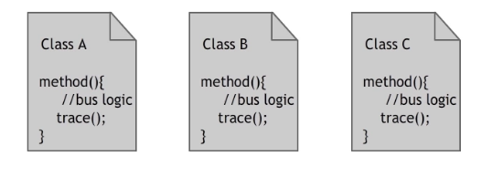

Trace() method is called in each of these class above along with business logic which is unclean. Trace() method is cross cutting concern here i.e a concern that cuts across all classes.

Now we can remove trace() method and create an aspect class that concerns only with tracing. Above is modified as

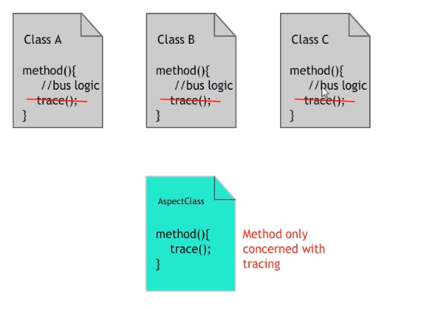

Spring will weave the aspects based on configurations and run the aspect. Now code is clean as all classes are concerned with business logic only and trace() method runs in a centralized location.

Terms

1. Aspect – Module that is responsible for providing cross cutting requirements. In Spring, it is typically a class
2. Advice – Actual code that implements cross cutting requirement. In Spring, it is typically a method
3. Join Point – Potential point in an application execution where we can plug in an aspect. In Spring, it is typically a method execution
4. Point Cuts – One or more joinpoints where aspect is executed
5. Introductions – introduce new methods or attributes to existing classes
6. Target object – methods that are being advised
7. Weaving – process of linking aspects with rest of the application types to create advised objects.

Create a Maven project. Add dependency

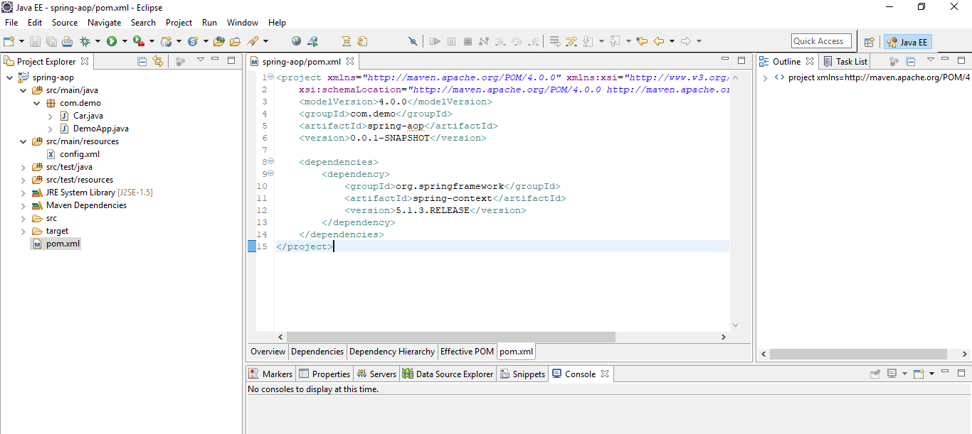

Create the Class car

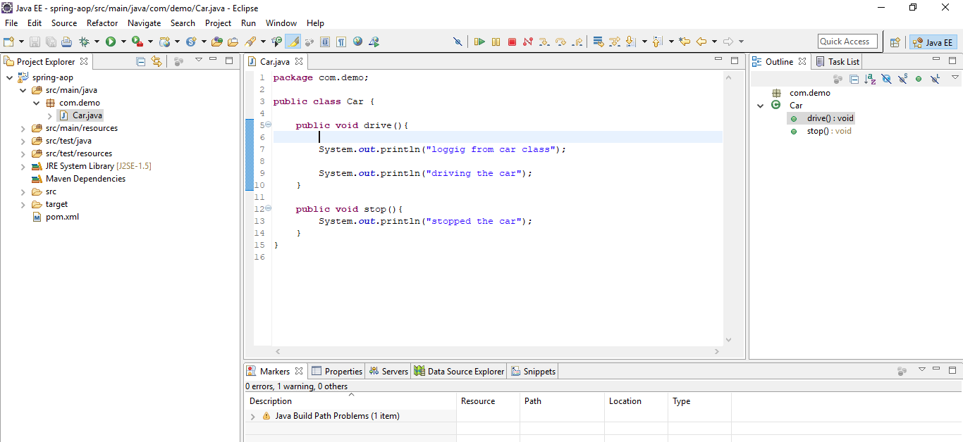

Create Config file

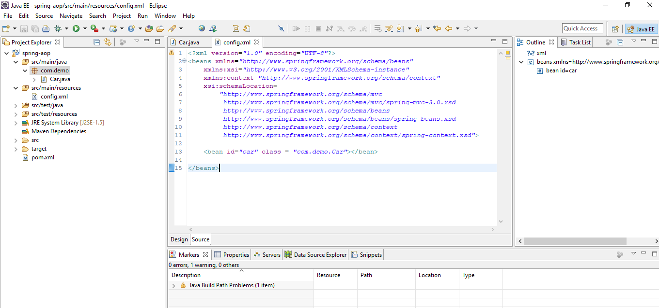

Create Main Application file

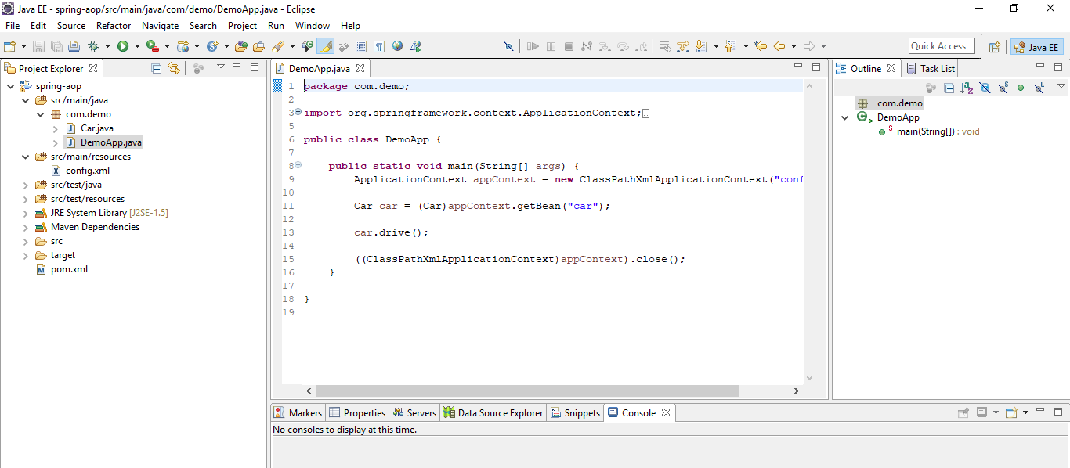

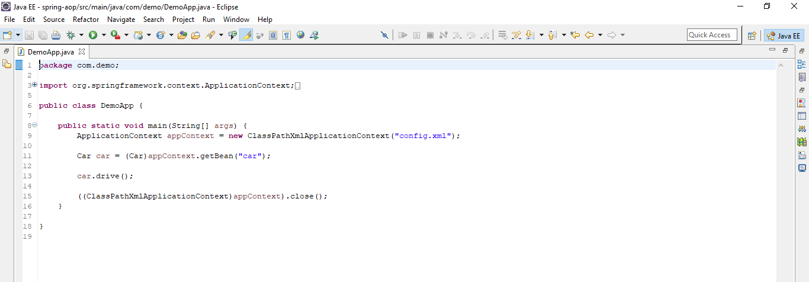

Run the main class

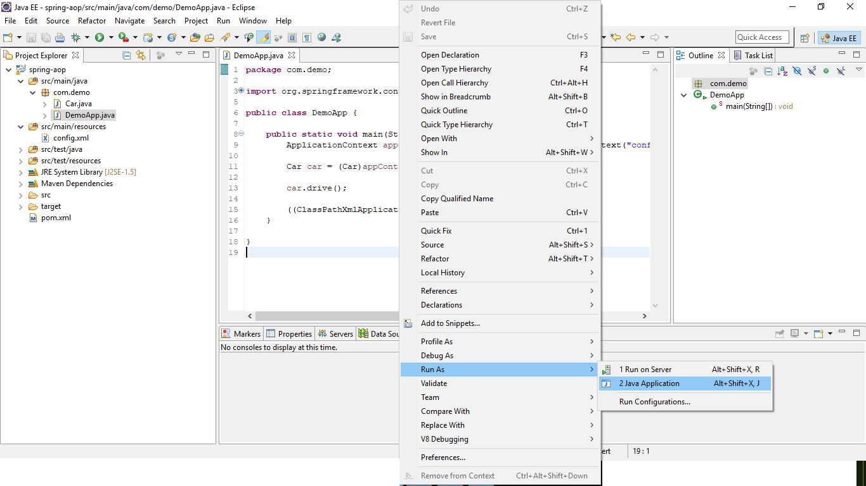

Verify the output

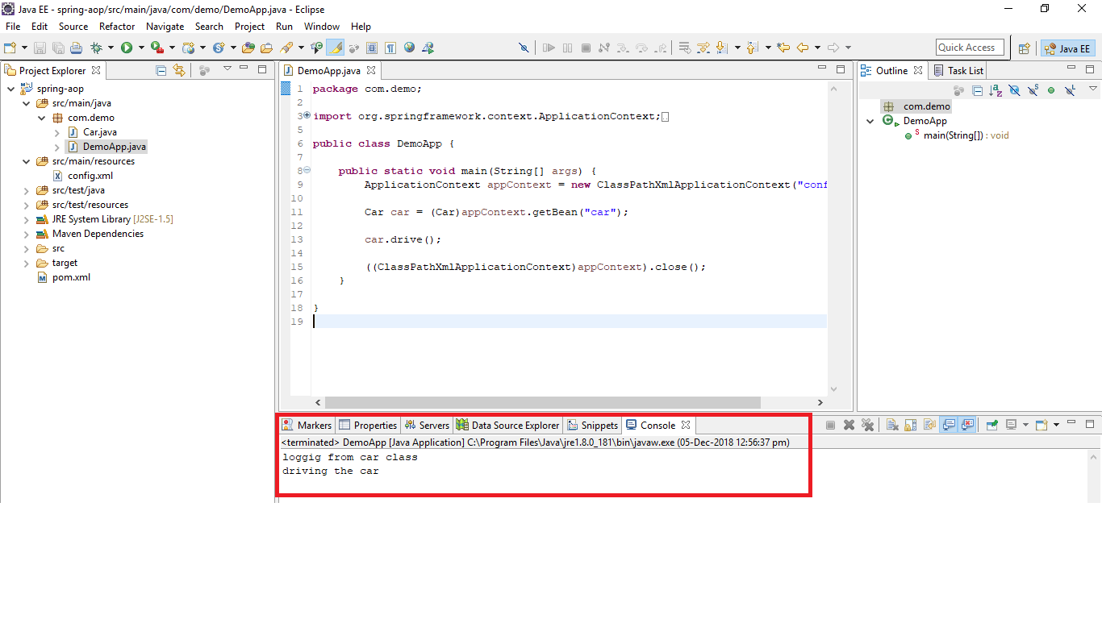

Let’s move the logging from Car class and use Spring AOP

Add a dependency

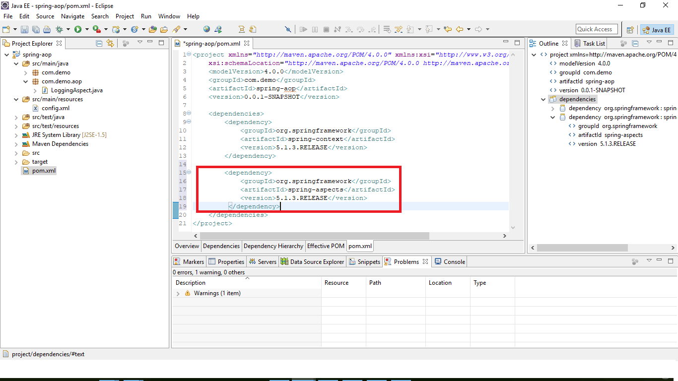

Commenting out the logging in car class

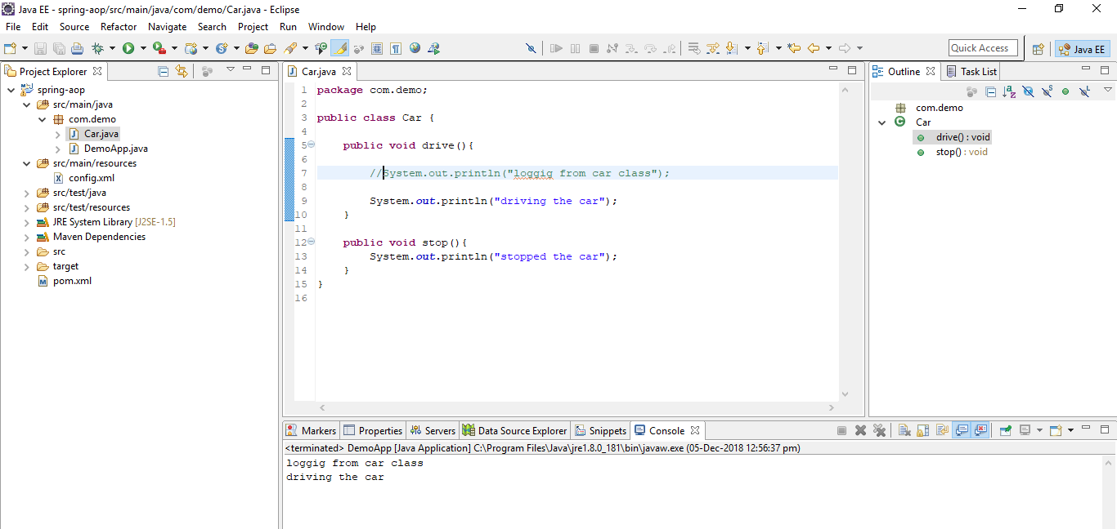

Create a Logging Aspect. LoggingAspect class in the aspect and log is the advice

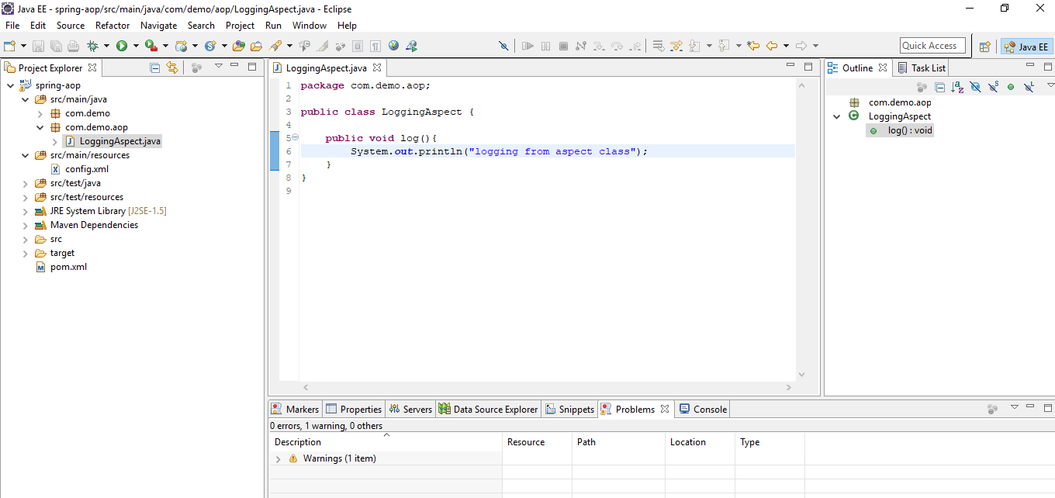

Create a bean for Logging aspect and add aop namespace in beans tag

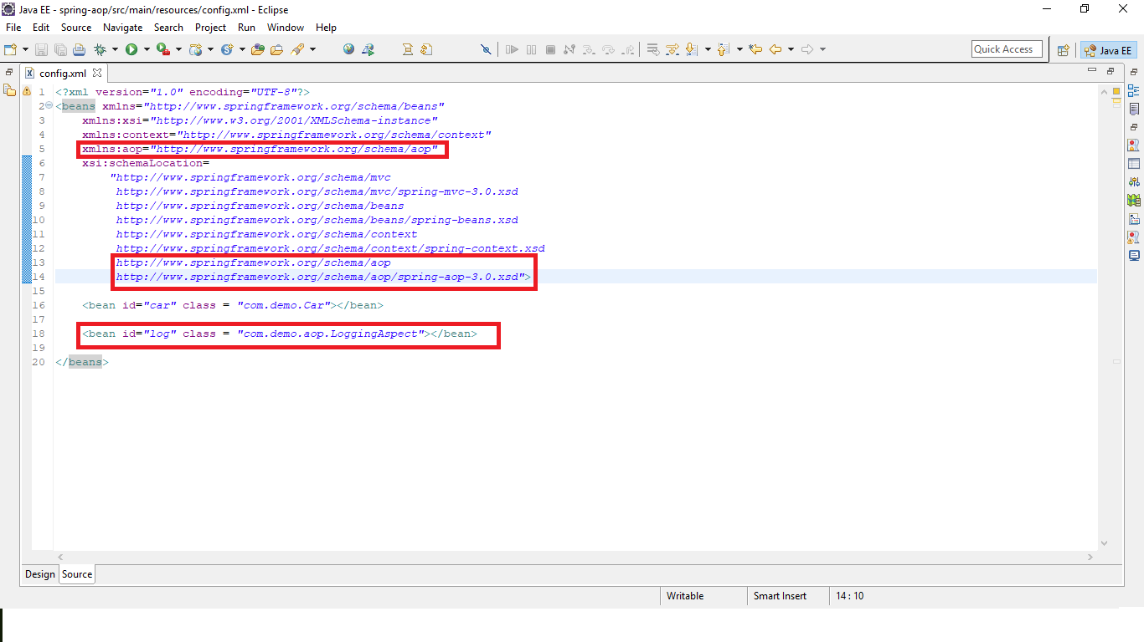

Configure AOP

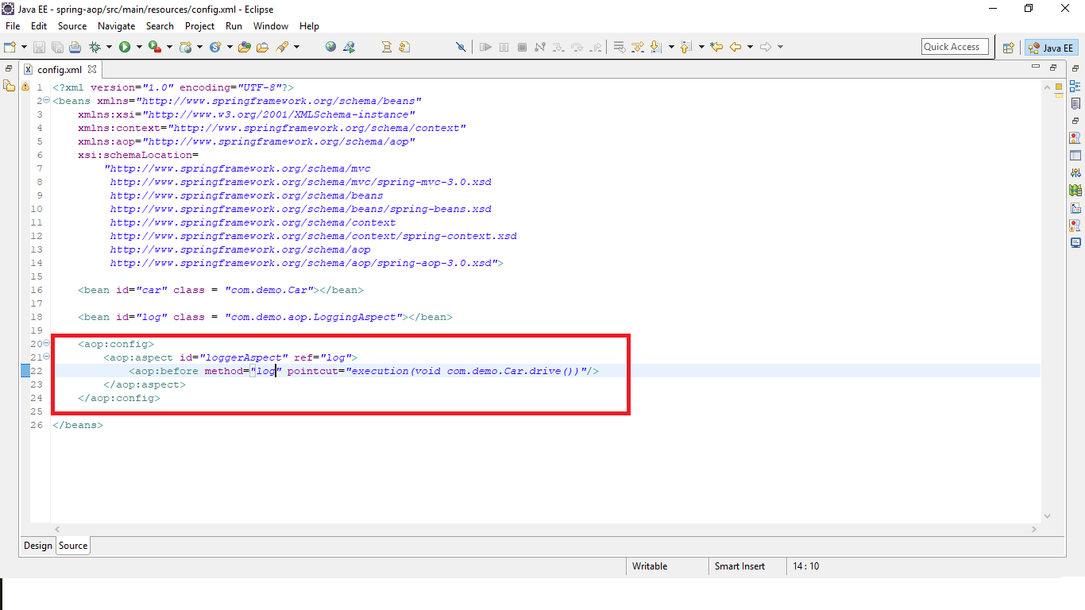

Aop:config – Configuration tag for Spring AOP

Aop:aspect – id attribute is unique name. ref attribute is reference to aspect bean

Aop:before – Before advice i.e runs the aspect before the pointcut expression. Method attribute is method name of the aspect class. Pointcut attribute here denotes the aspect should run on method execution i.e method drive in class Car. Now aspect method log() runs before drive method (advise) in class Car is executed(pointcut)

Verify



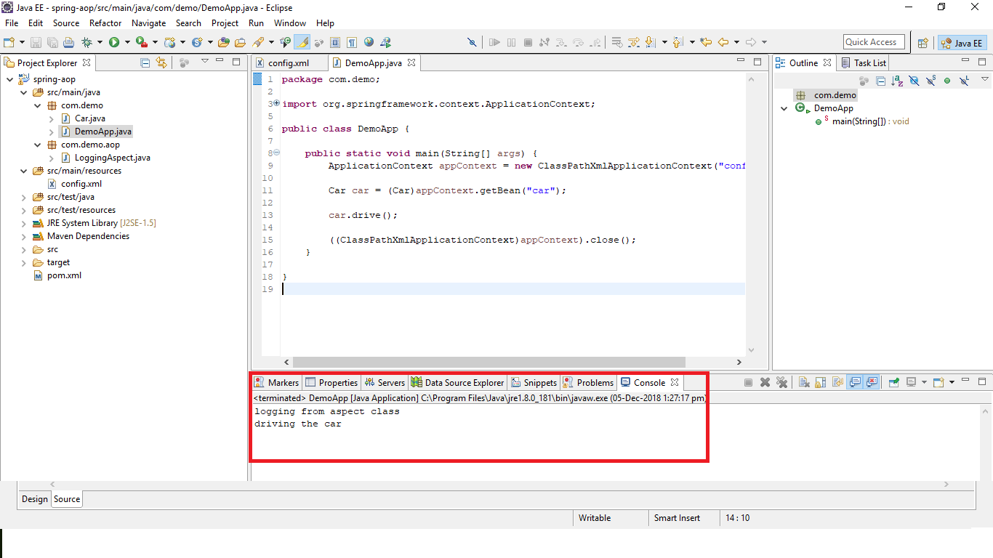

Creating re-usable pointcut expression

Use tag aop:pointcut to define pointcut expression. Use pointcut-ref to point to that pointcut id.

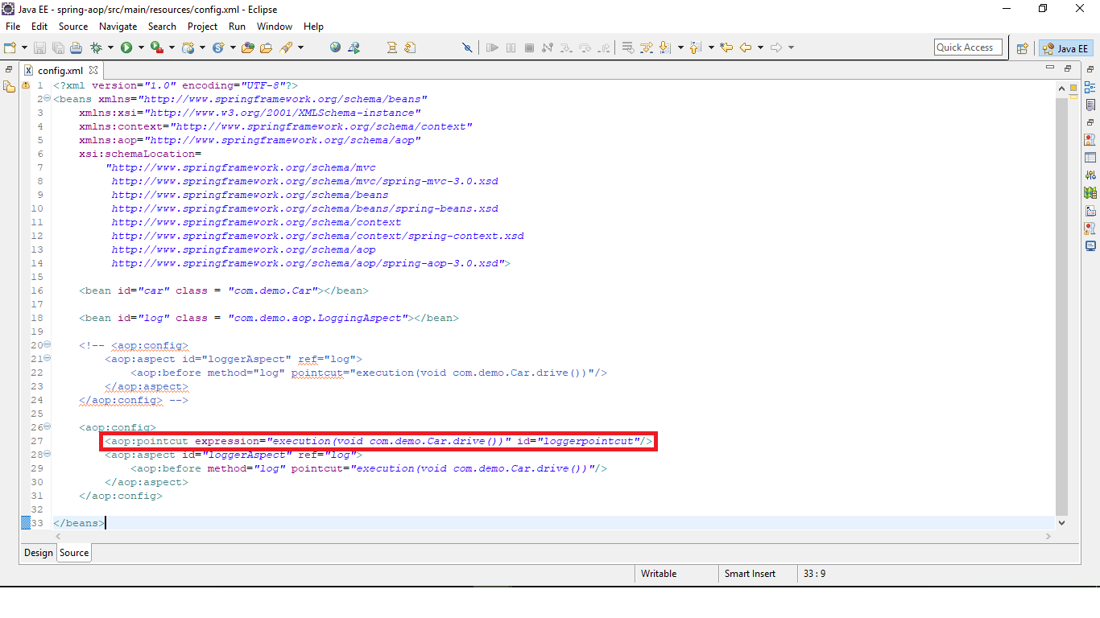

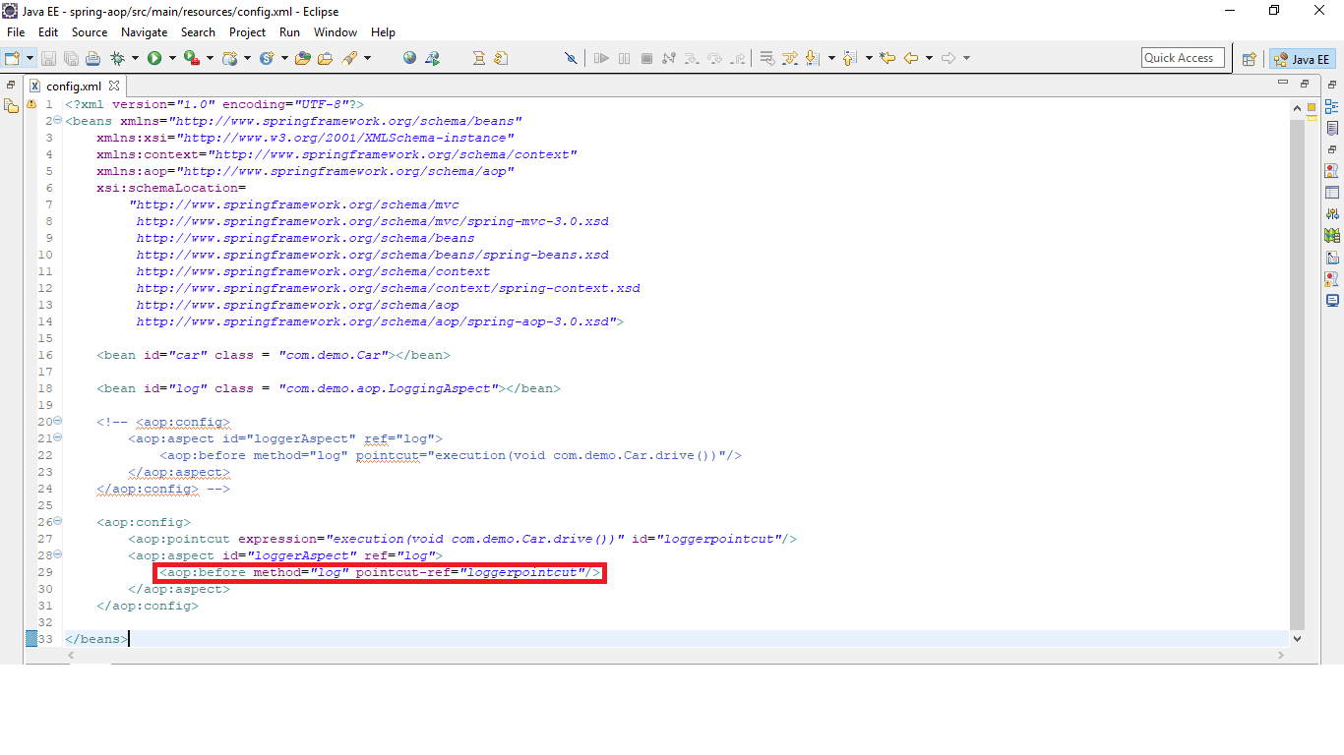

Annotation based config

Create the tag context:annotation-config in config xml

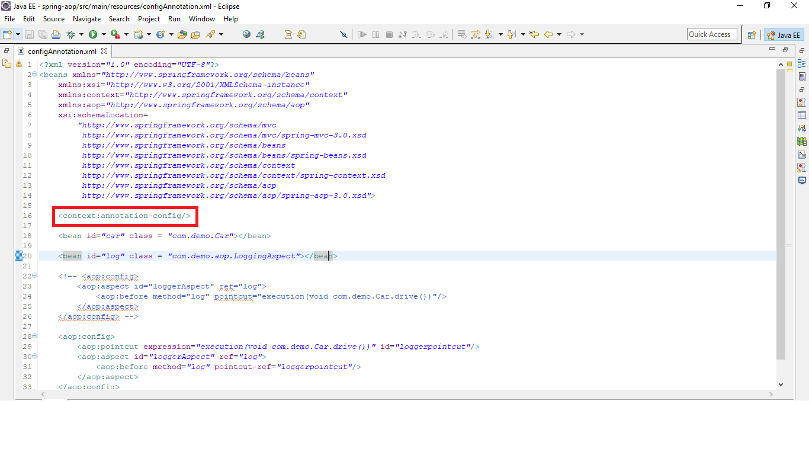

Comment out the log bean and aspect config

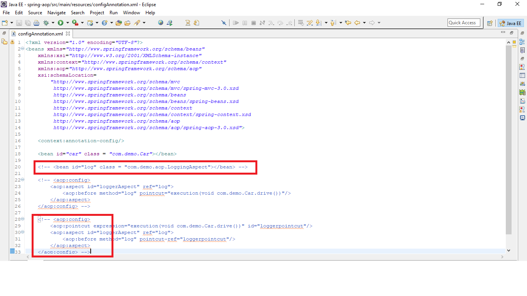

Configure this tag aop:aspectj-autoproxy. This is AspectJ of declaring annotations on aspects. This will wire aspect components that are annotated with @Aspect

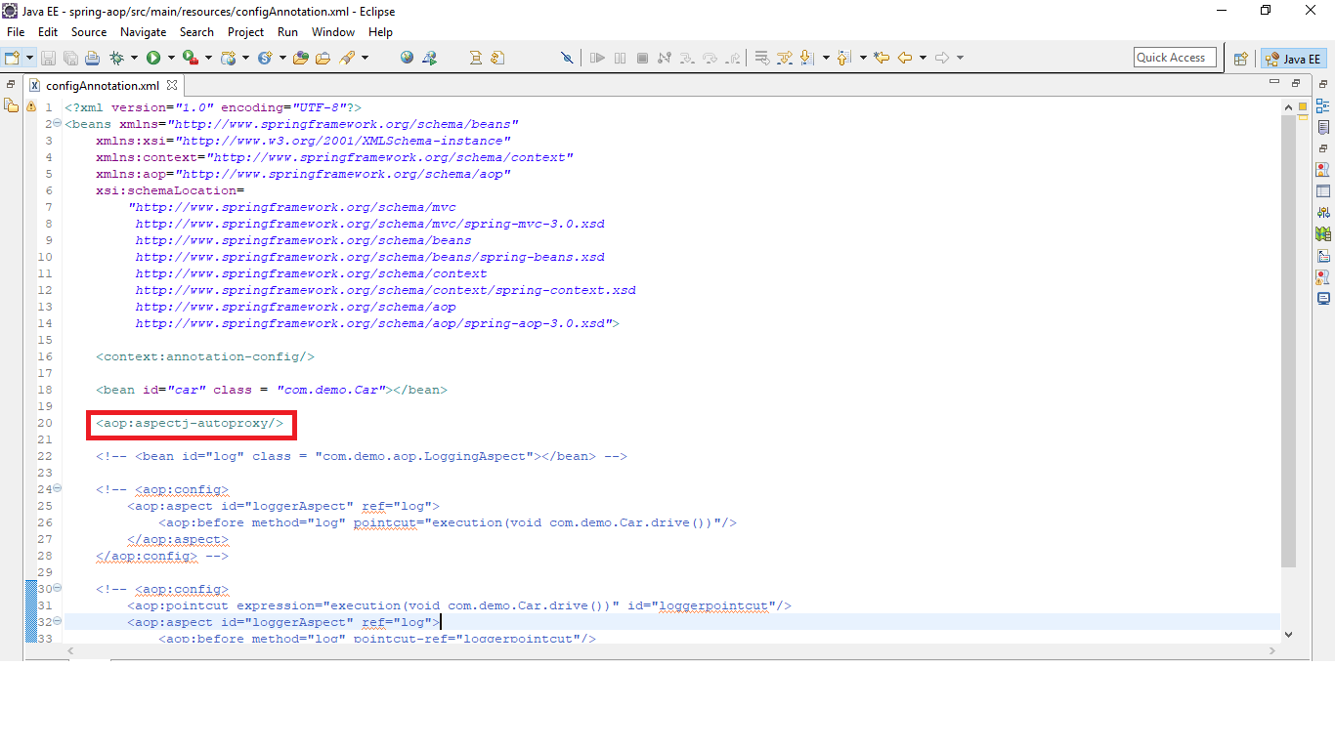

Configure base packages in context:component-scan tag to scan for annotations

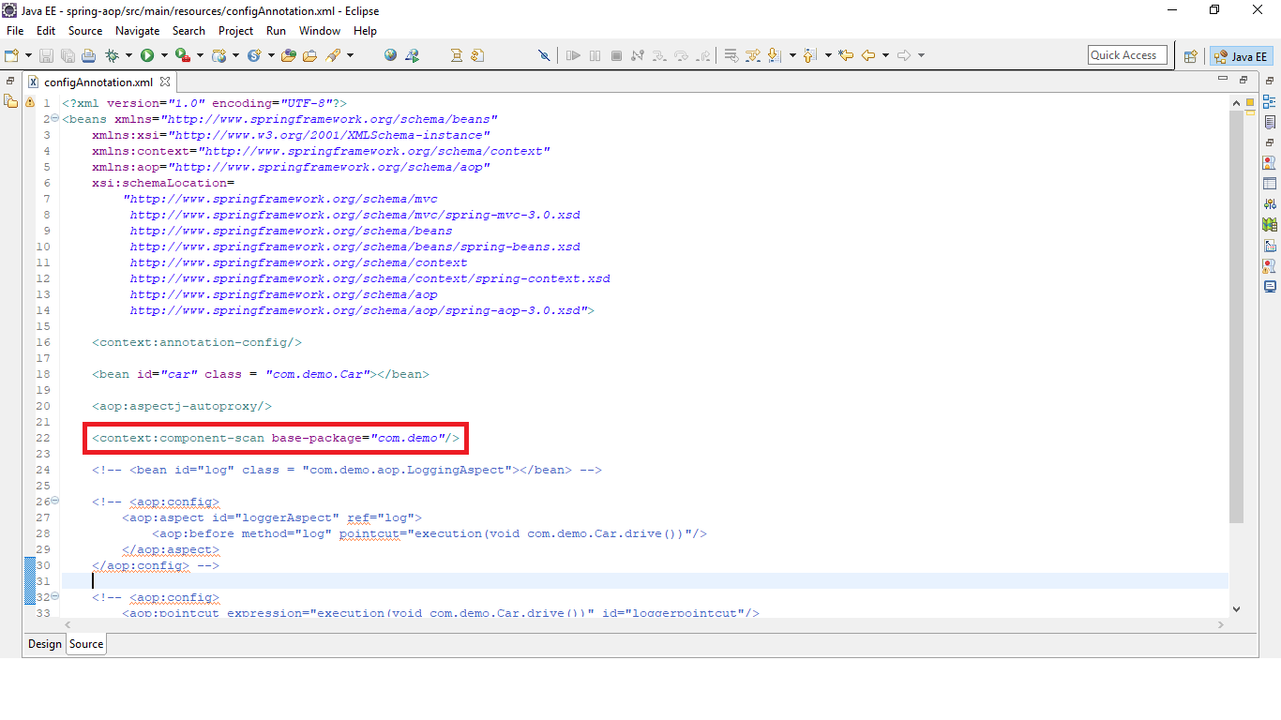

Create a new class LoggingAspectAnnotation and Configure LoggingAspect class as a spring bean by annotating with @Component

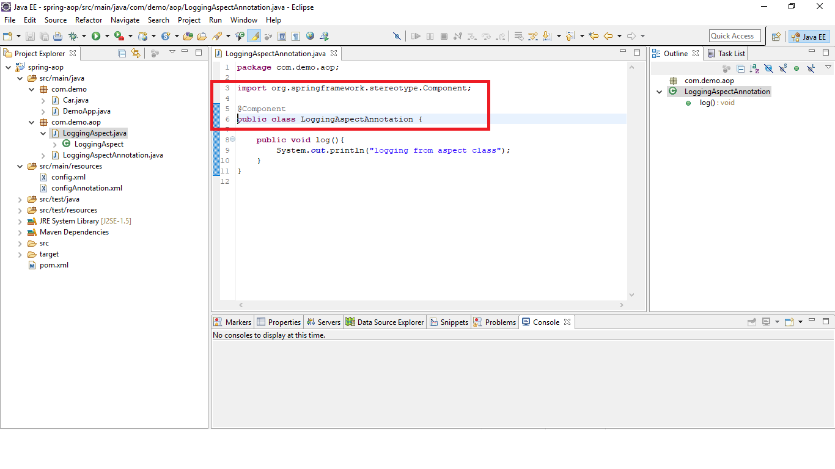

Add @Aspect annotation to make the class as Aspect class

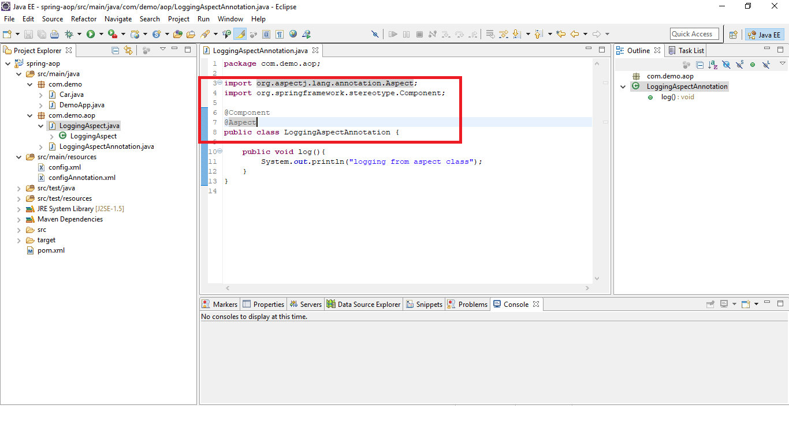

Configure advise on the advise method

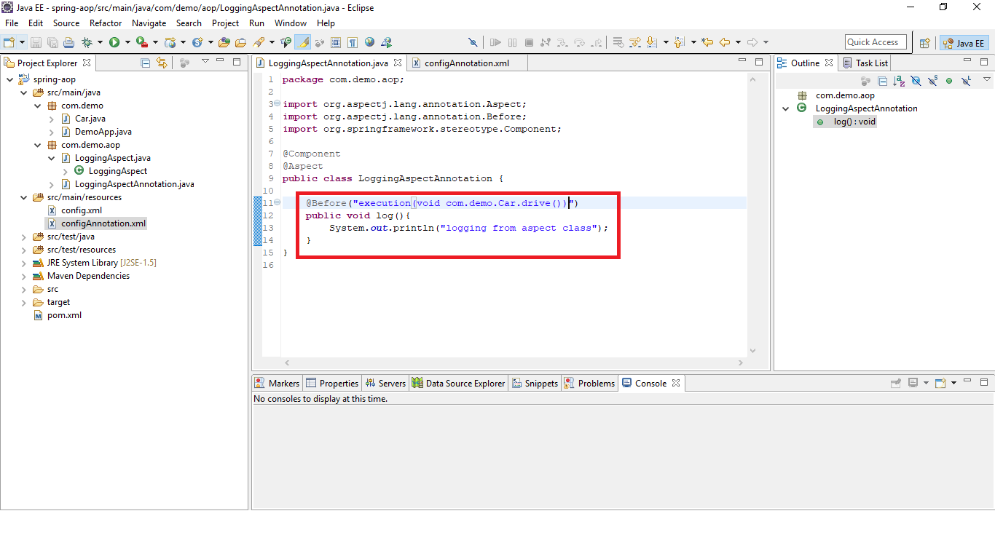

Aspect with method parameters

Change Car class to have method with params

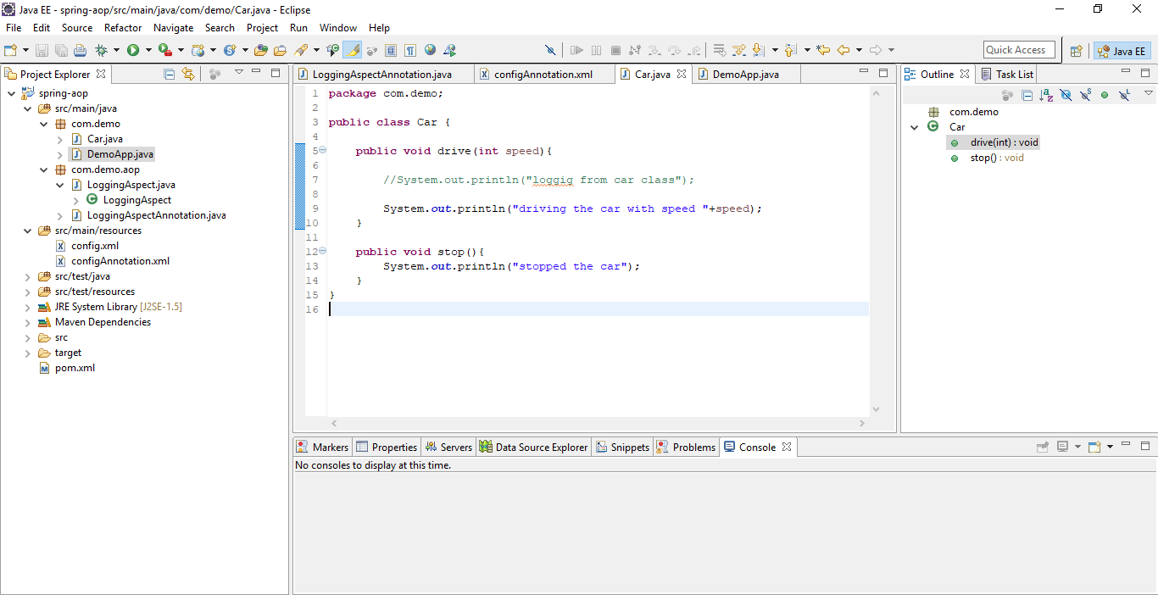

Change Advise to accept parameters. (..) denotes any number of parameters

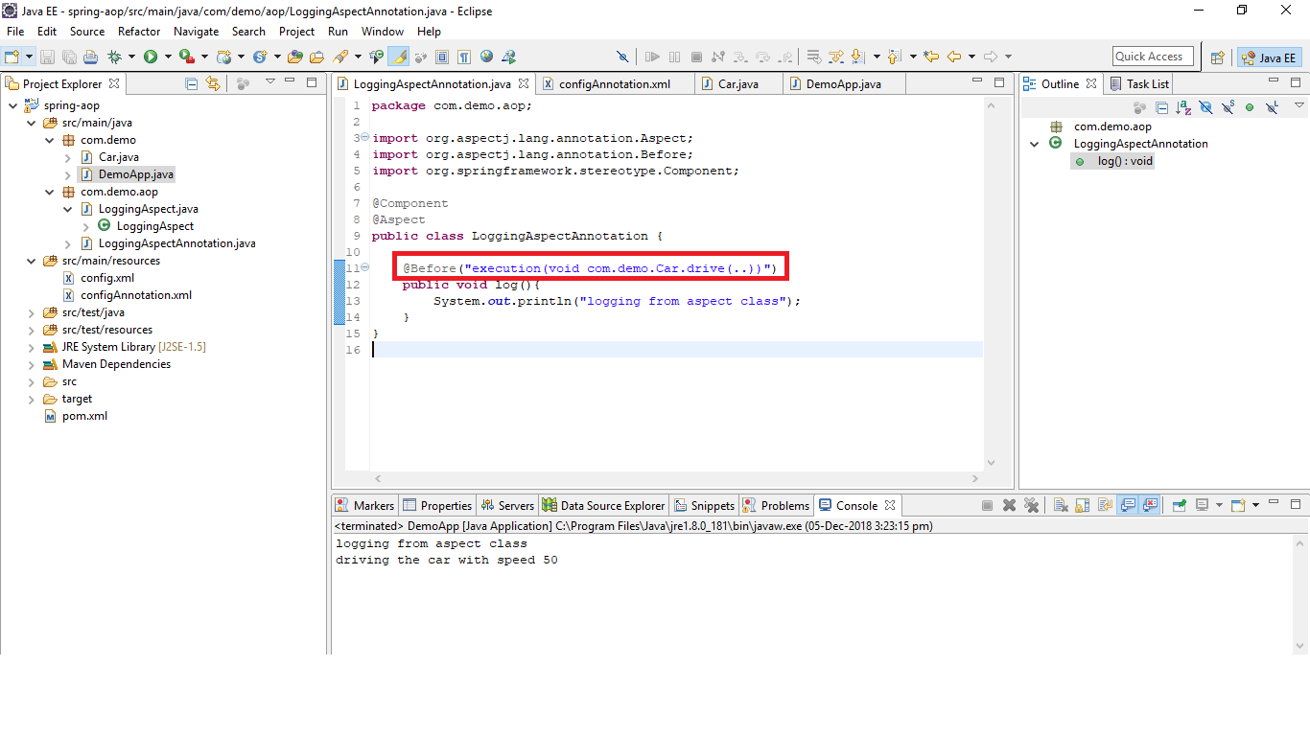

Get Joinpoint info – change the method log

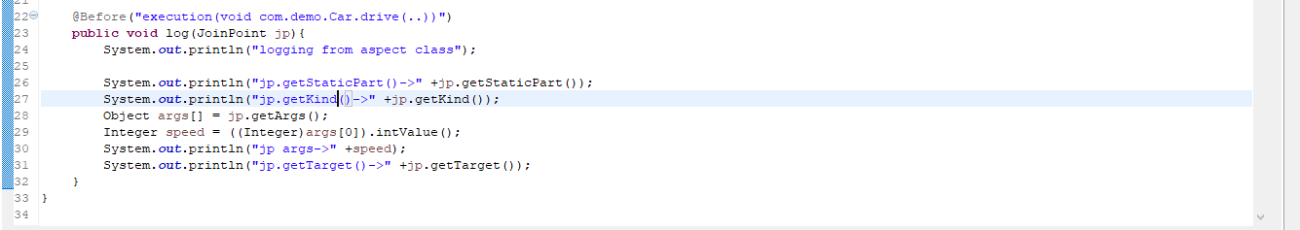

Run to see the output

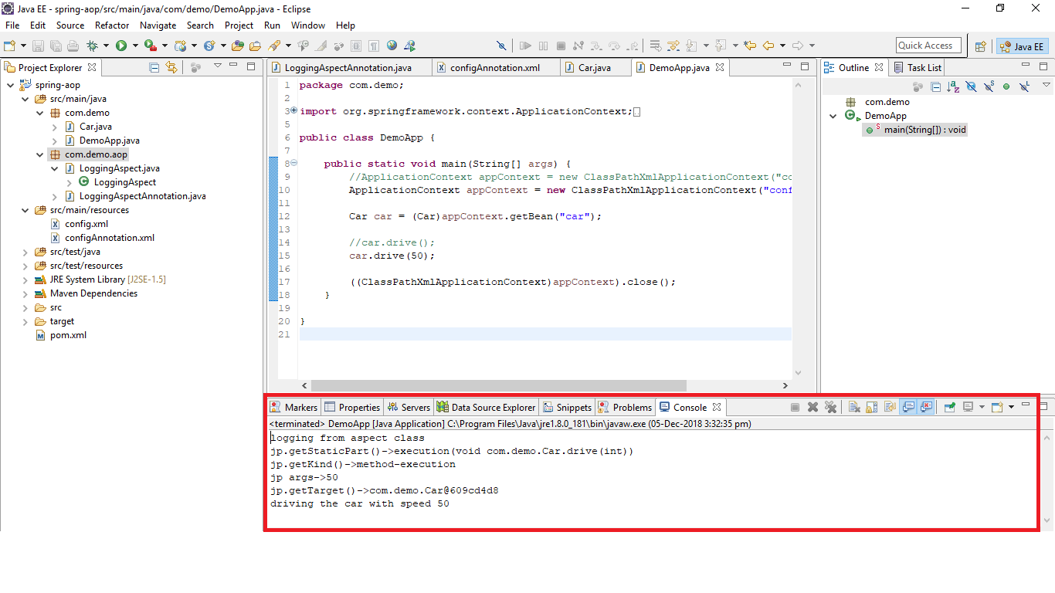

AOP with Spring Annotations

Create a configuration bean class

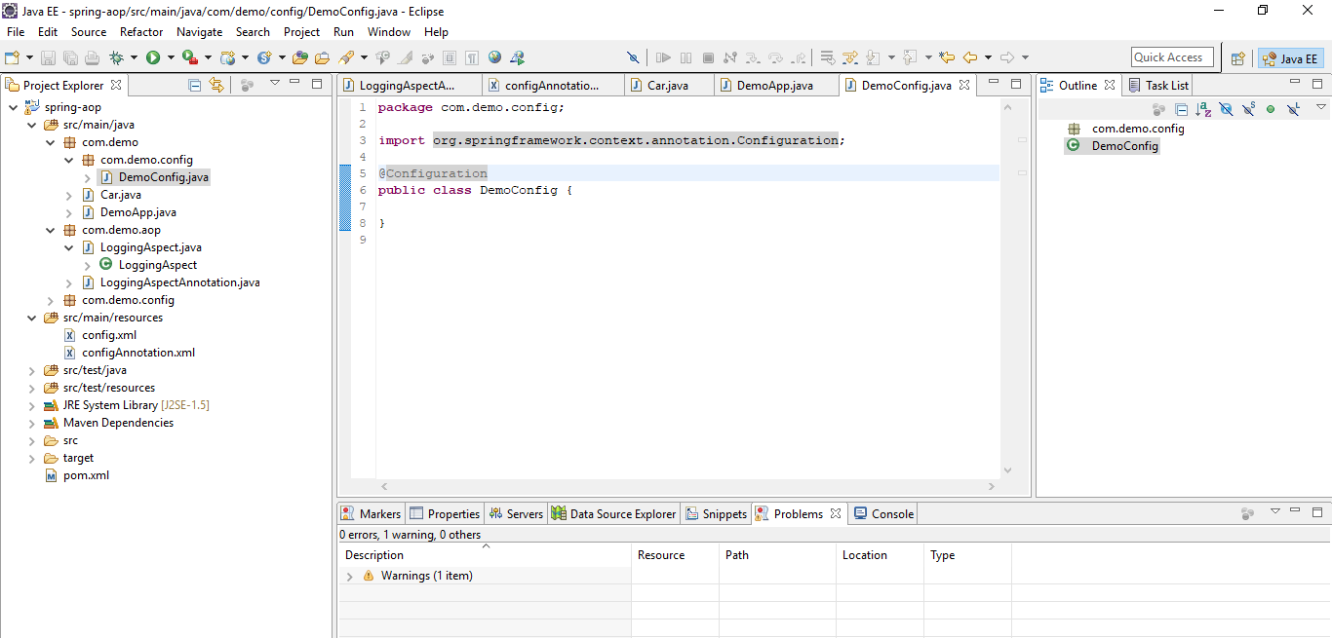

Add @ComponentScan annotation i.e to scan packages for spring beans

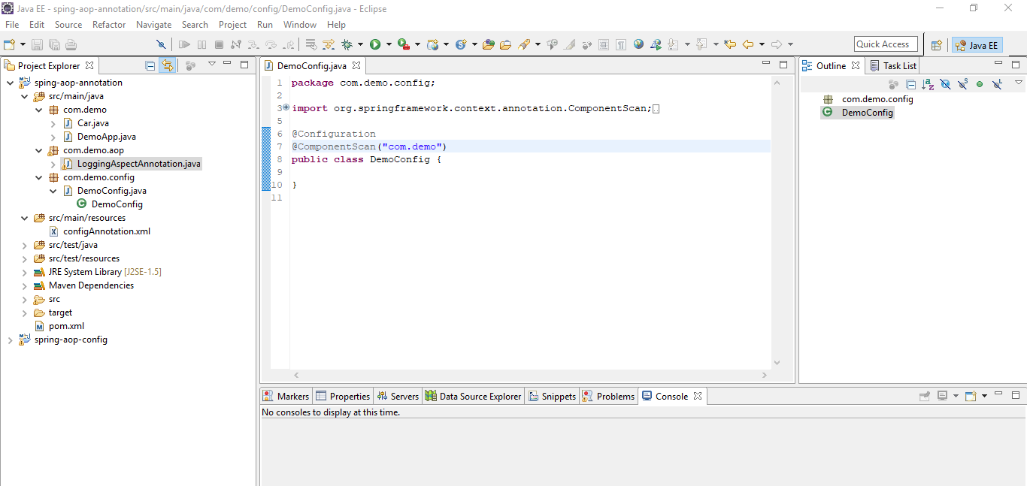

Add EnableAspectJAutoProxy to scan for aspect beans

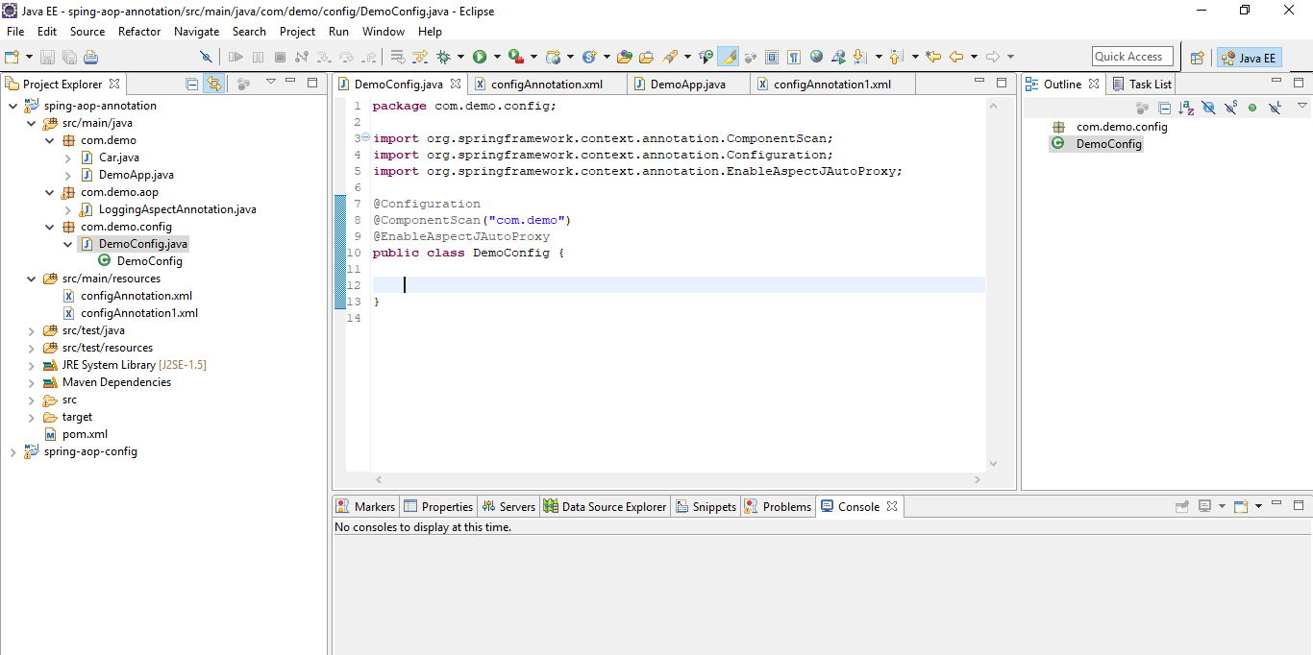

Create a bean using Annotation

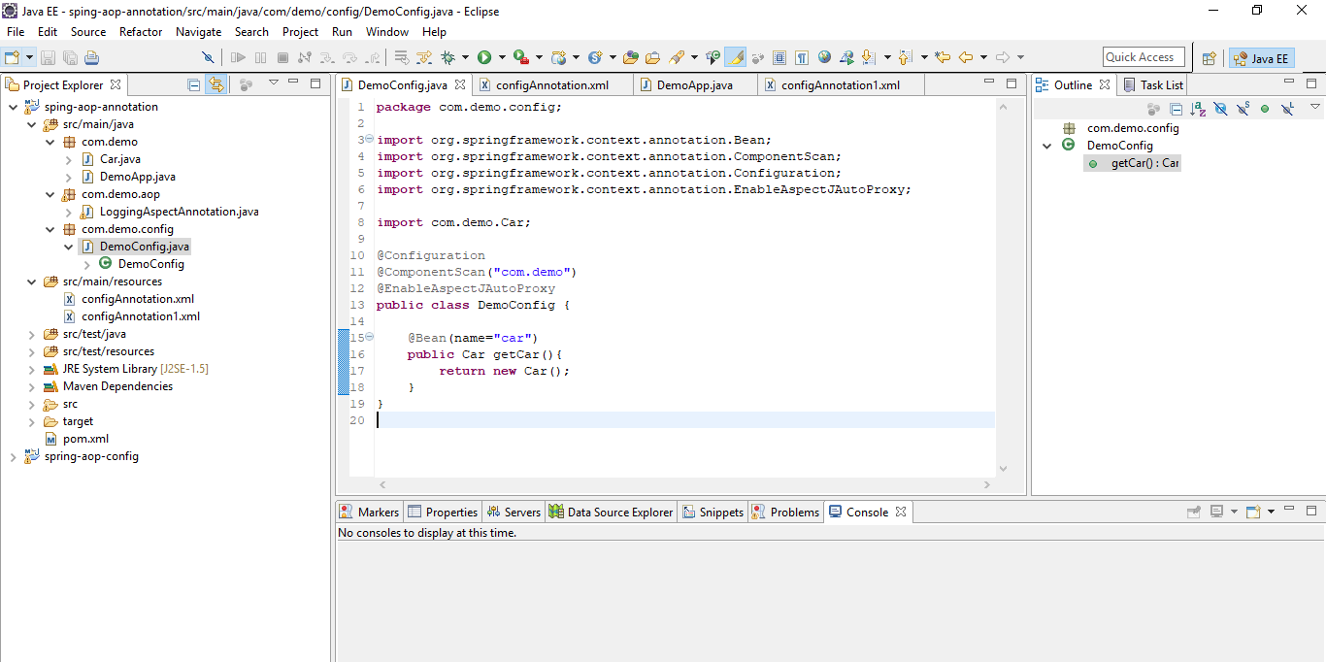

Run the application as Java based application

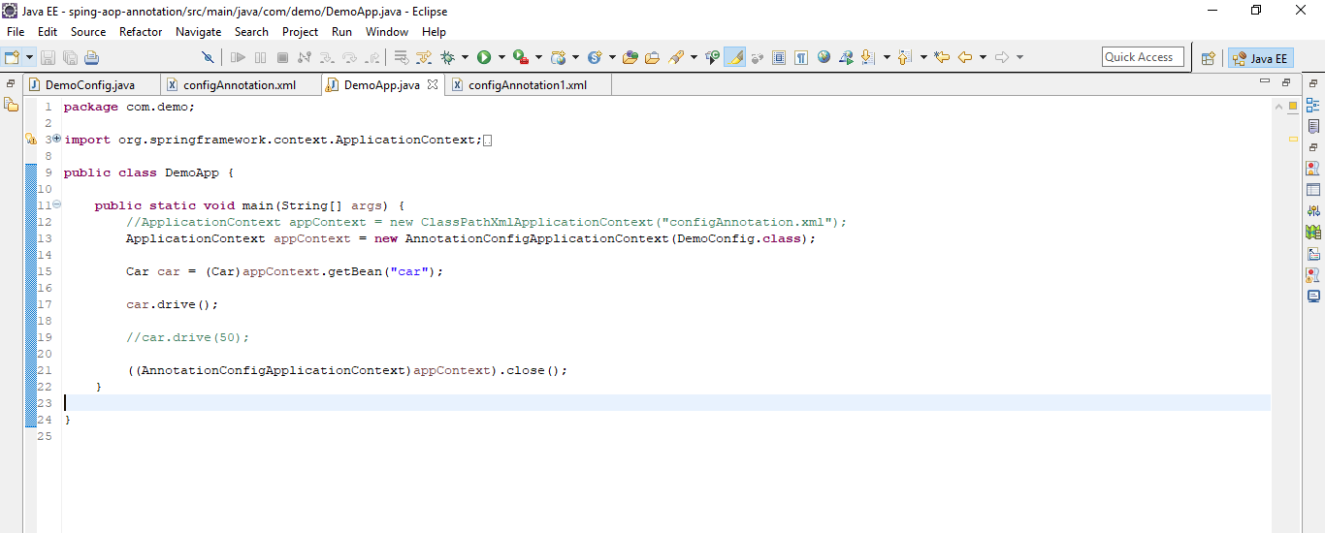

Verify the output

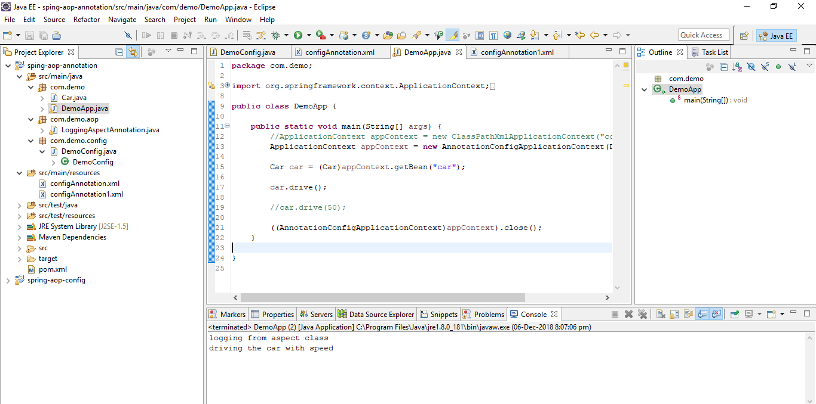

Advise

Method that is invoked to implement a cross cutting concern

Before Advise

Advise runs before a pointcut expression

If advise throws exception, actual method won’t run. Otherwise advise runs regardless of whatever happens inside the class

Example: Introduce an exception in advise method

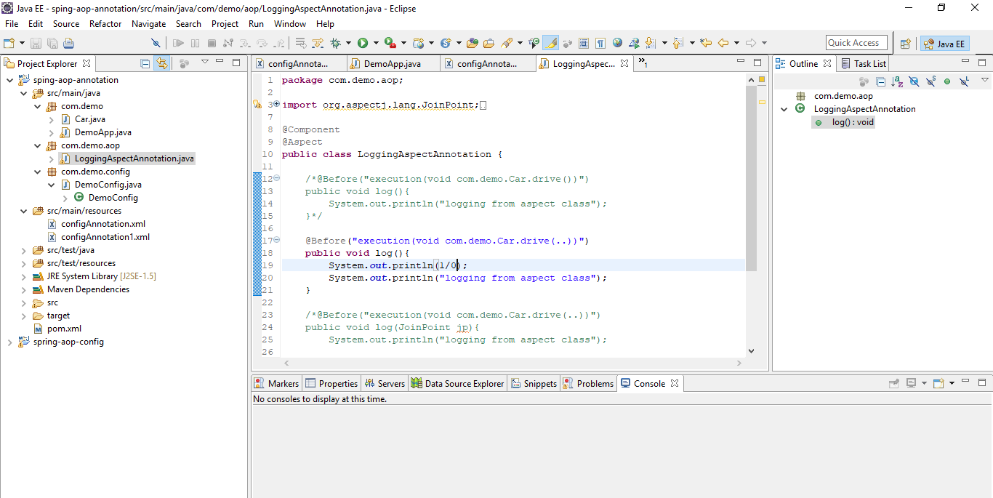

Now car drive method wont be called

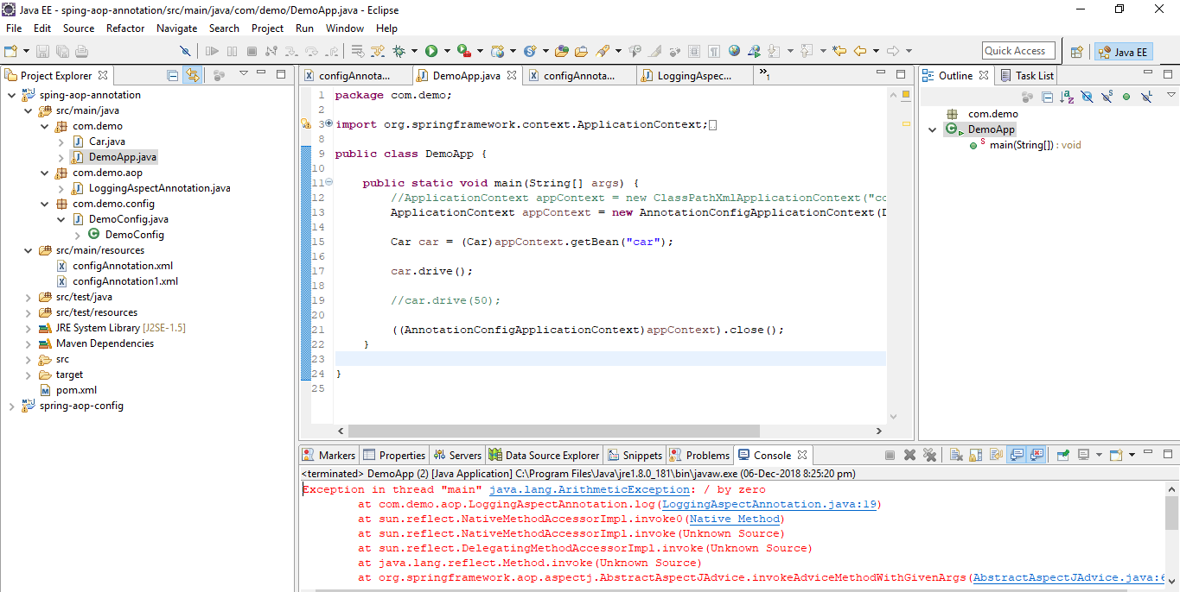

Throw an exception from advise if you don’t want application to stop and catch it in main class

Example:

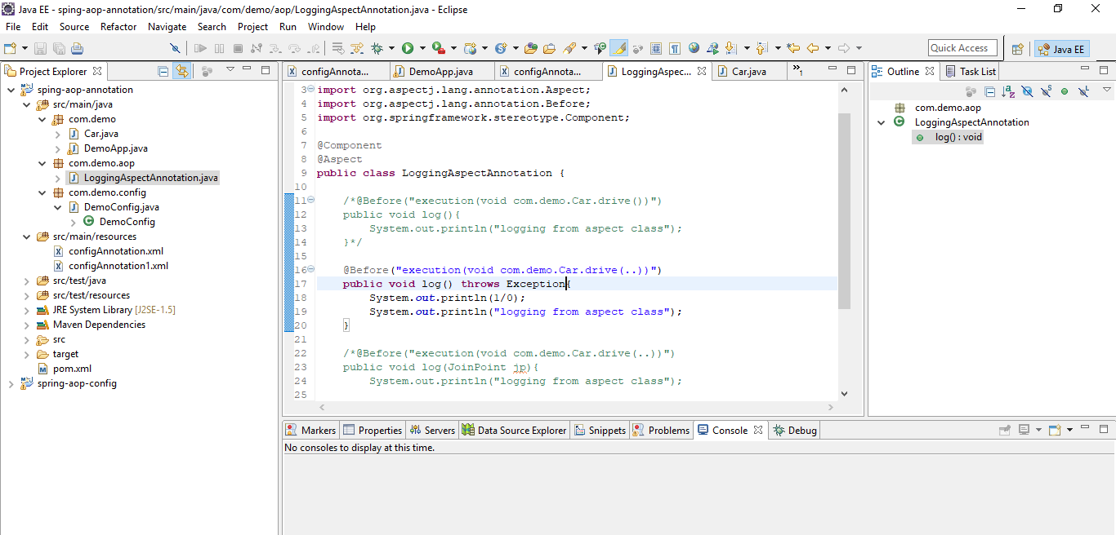

Main class

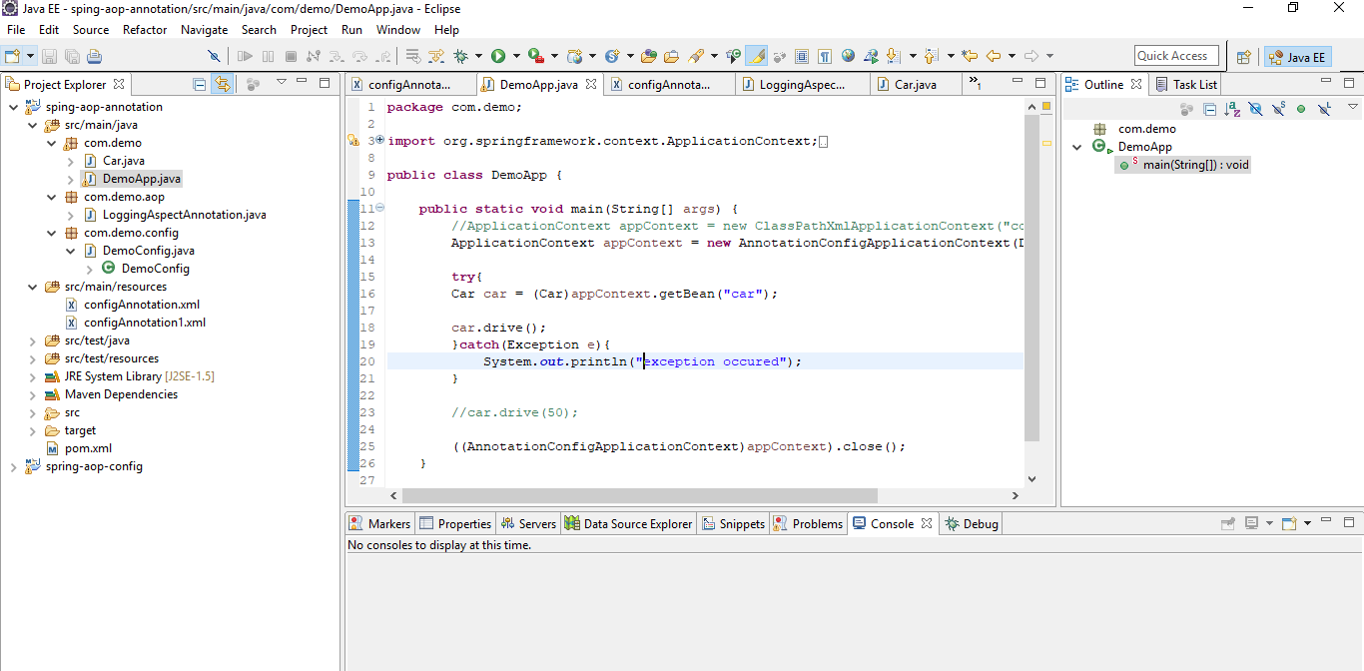

After returning advise

Advise runs after a pointcut expression if the method returns normally

Create a new method that returns a value

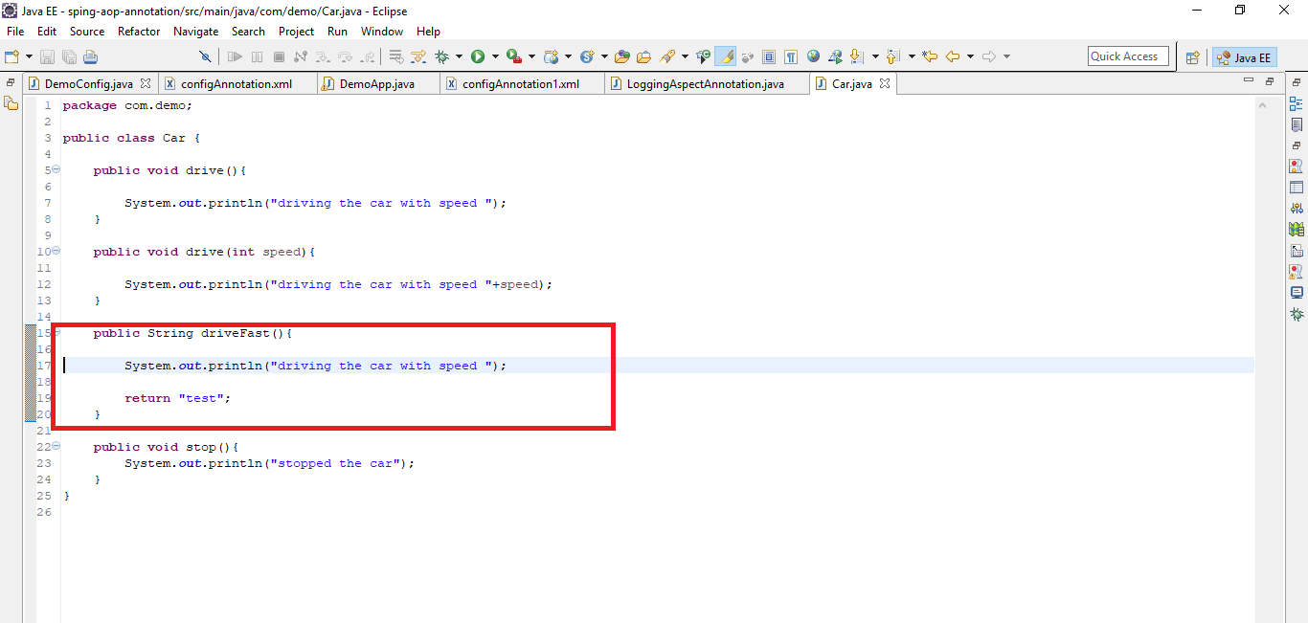

Configure after returning advise

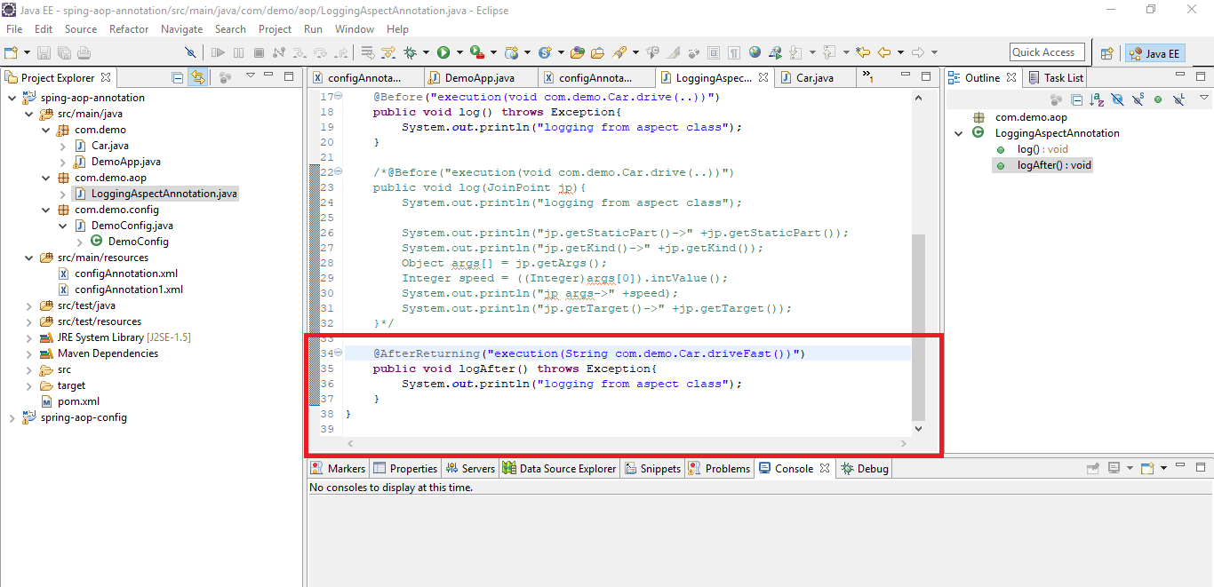

Call this method and run the main class

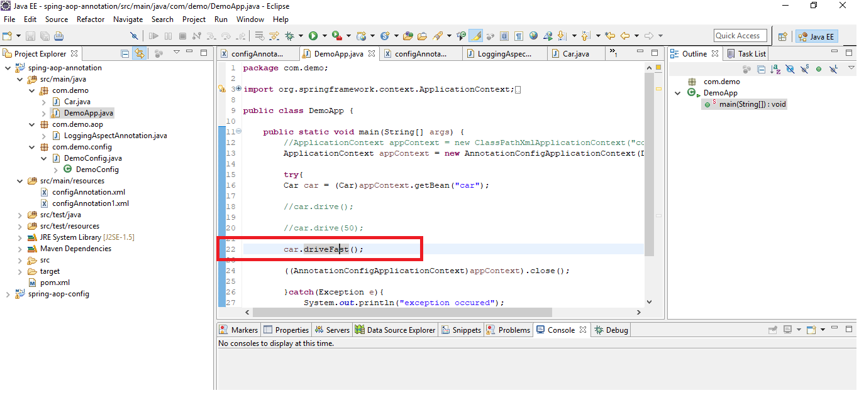

Run

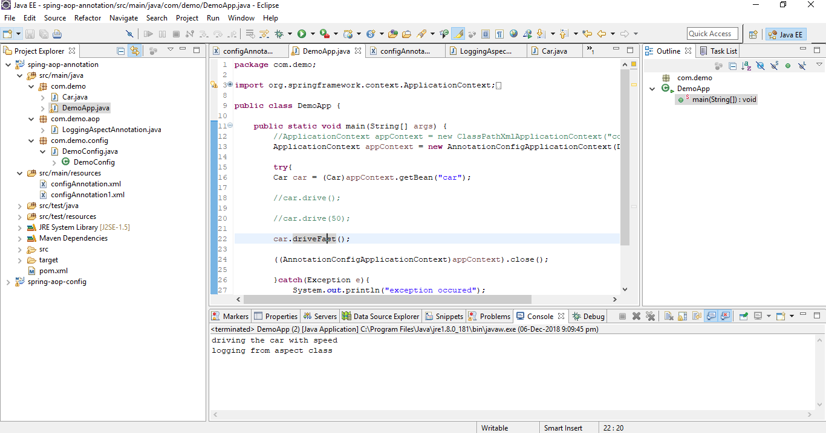

If method throws an exception, advise wont run

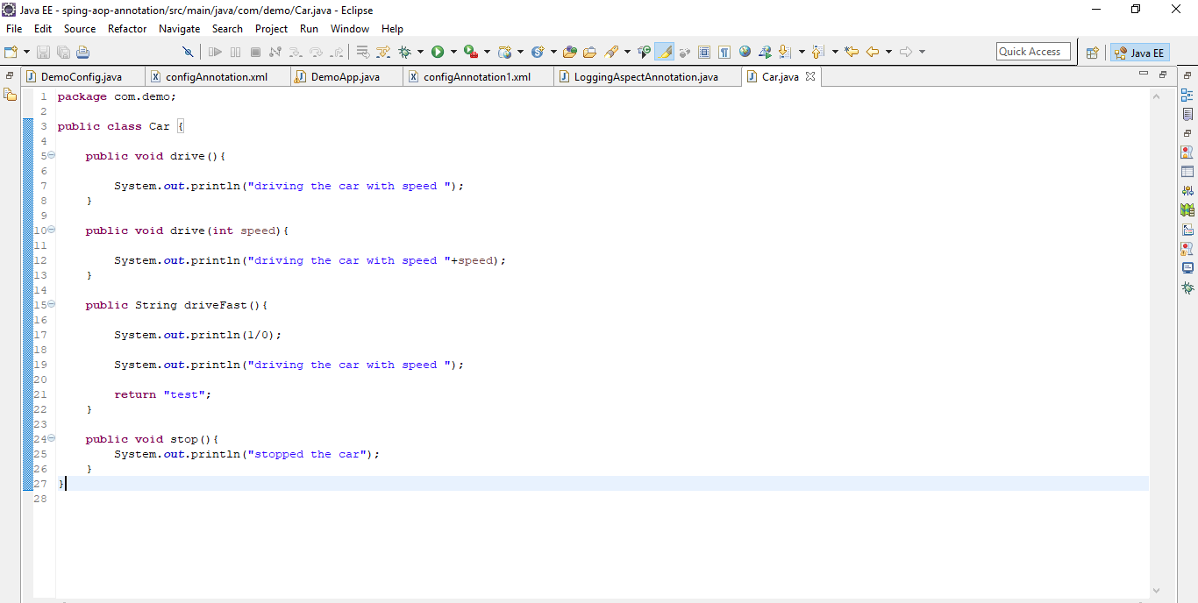

Run

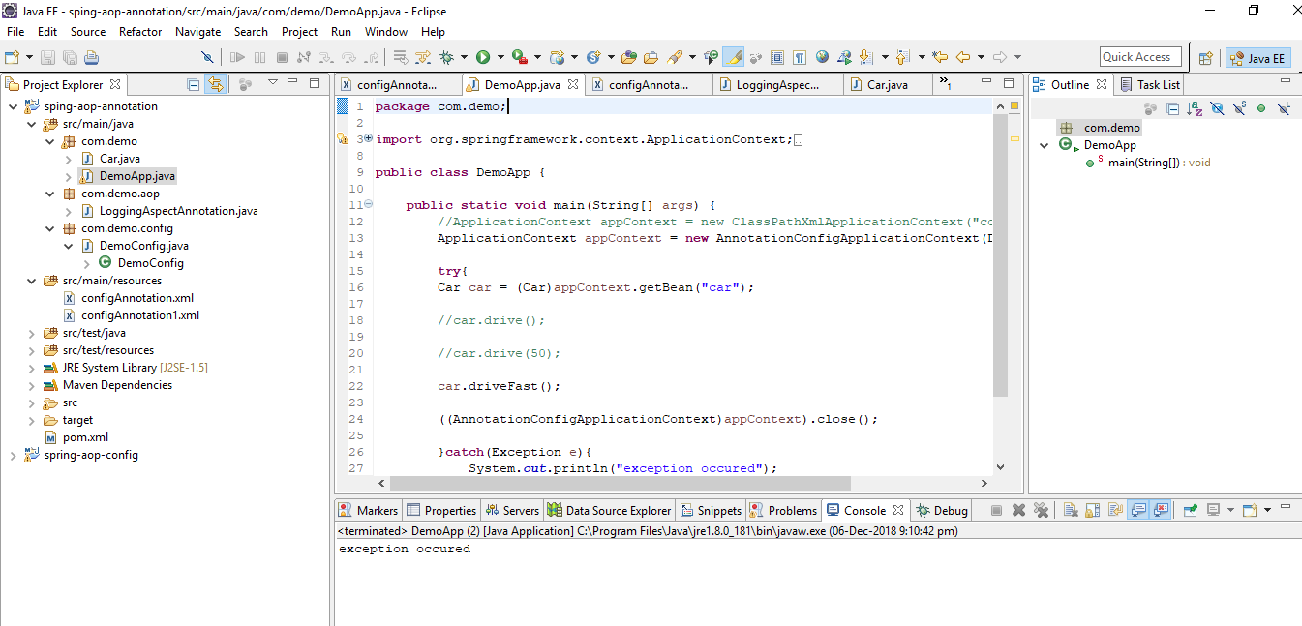

Capture return value

Store the returned value in returning attribute and use it in param

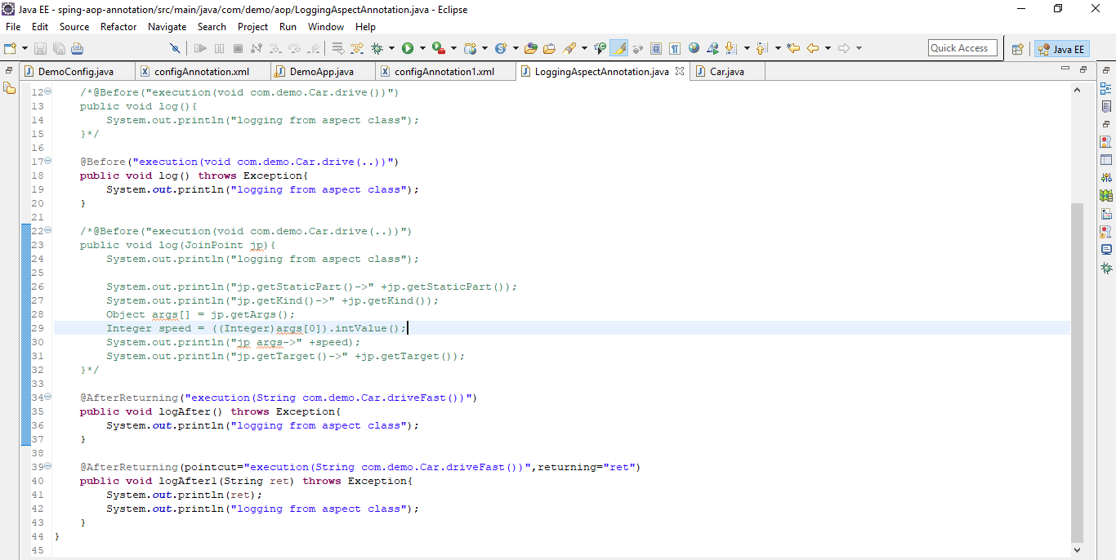

Run

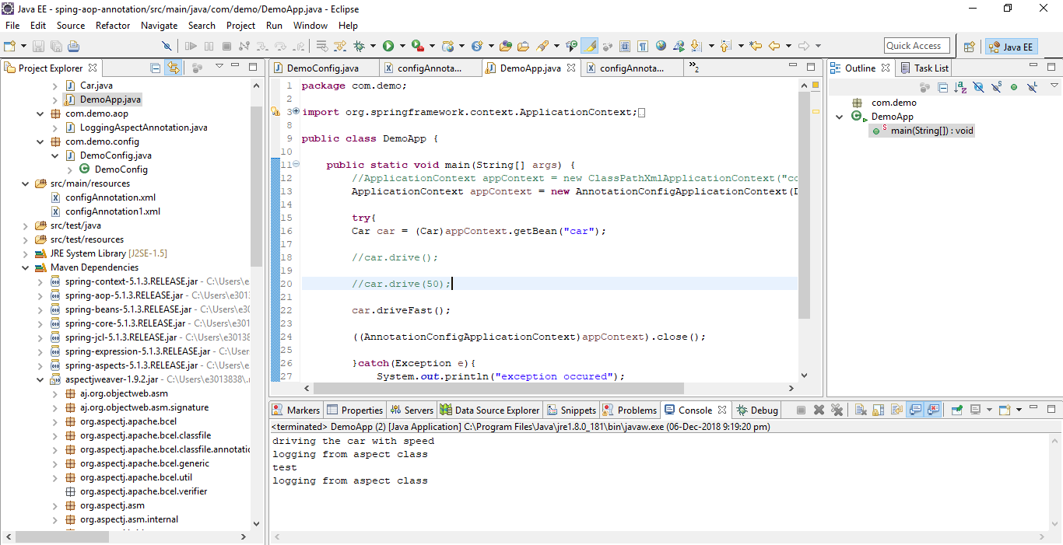

After throwing

Advise runs after a pointcut expression only if the method throws an exception

Create a method that throws exception

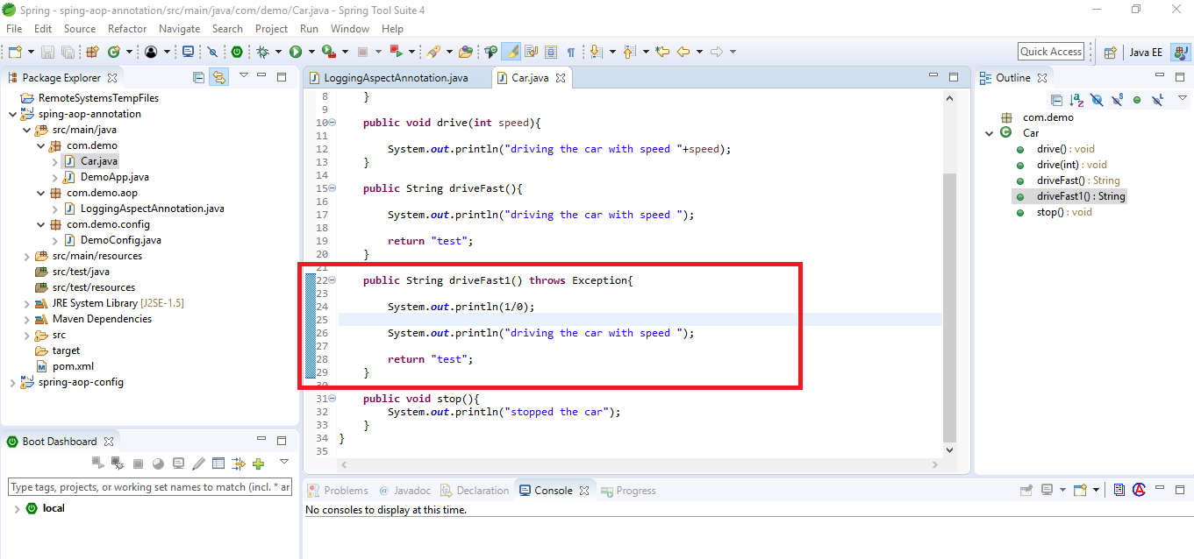

Create an afterthrowing advice

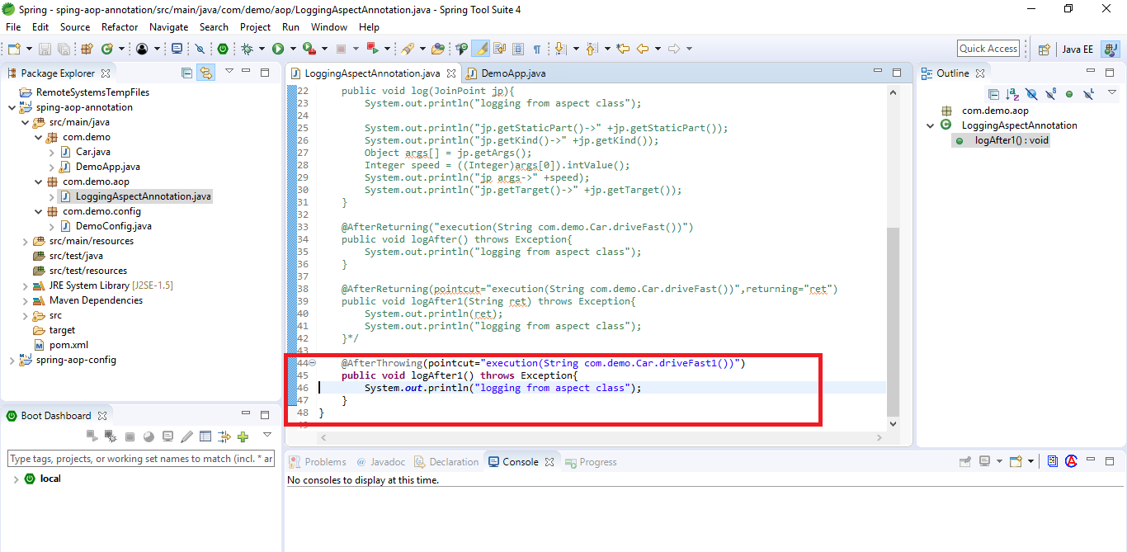

Run

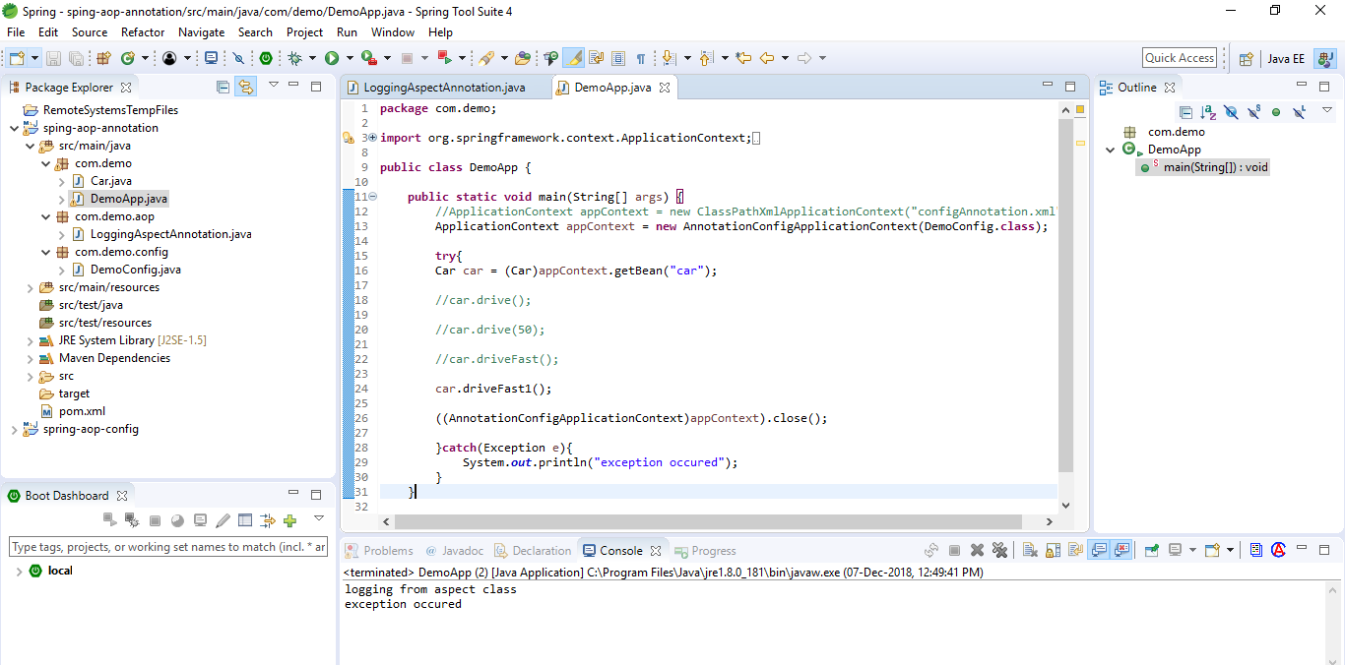

Capture the exception type using throwing

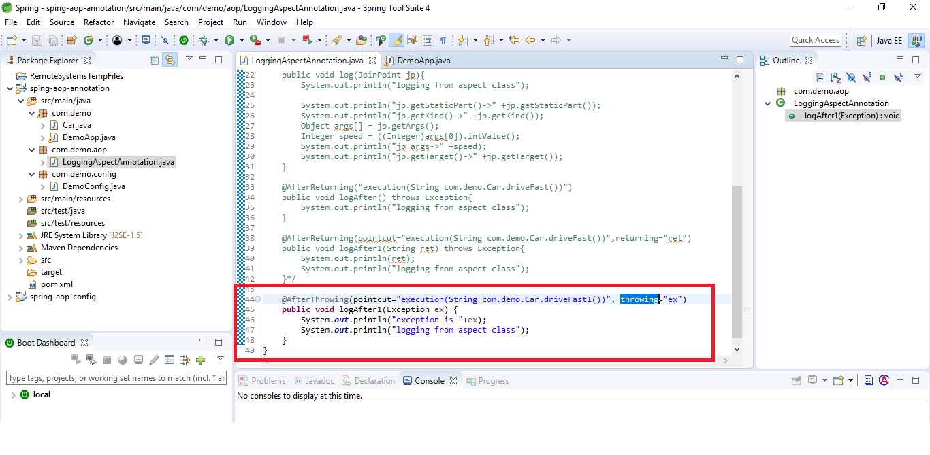

Run

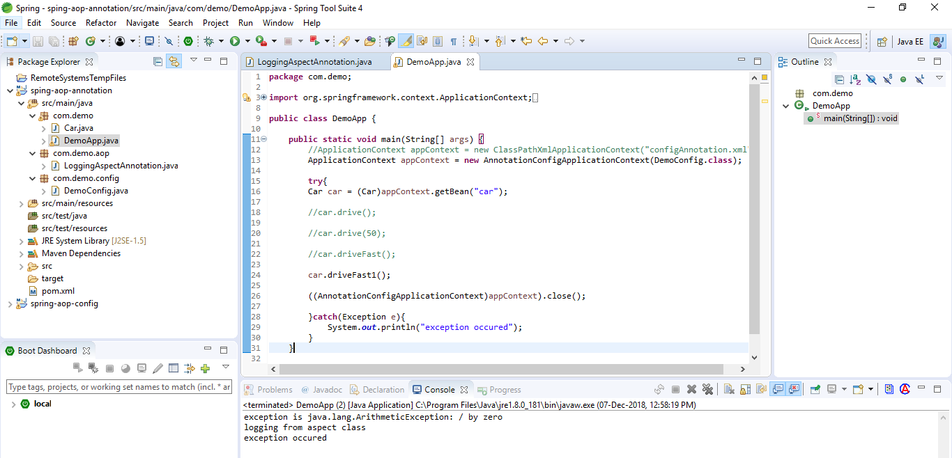

After (finally) advice

Advise runs after a pointcut expression only if the method returns normally or not

Configure After advise

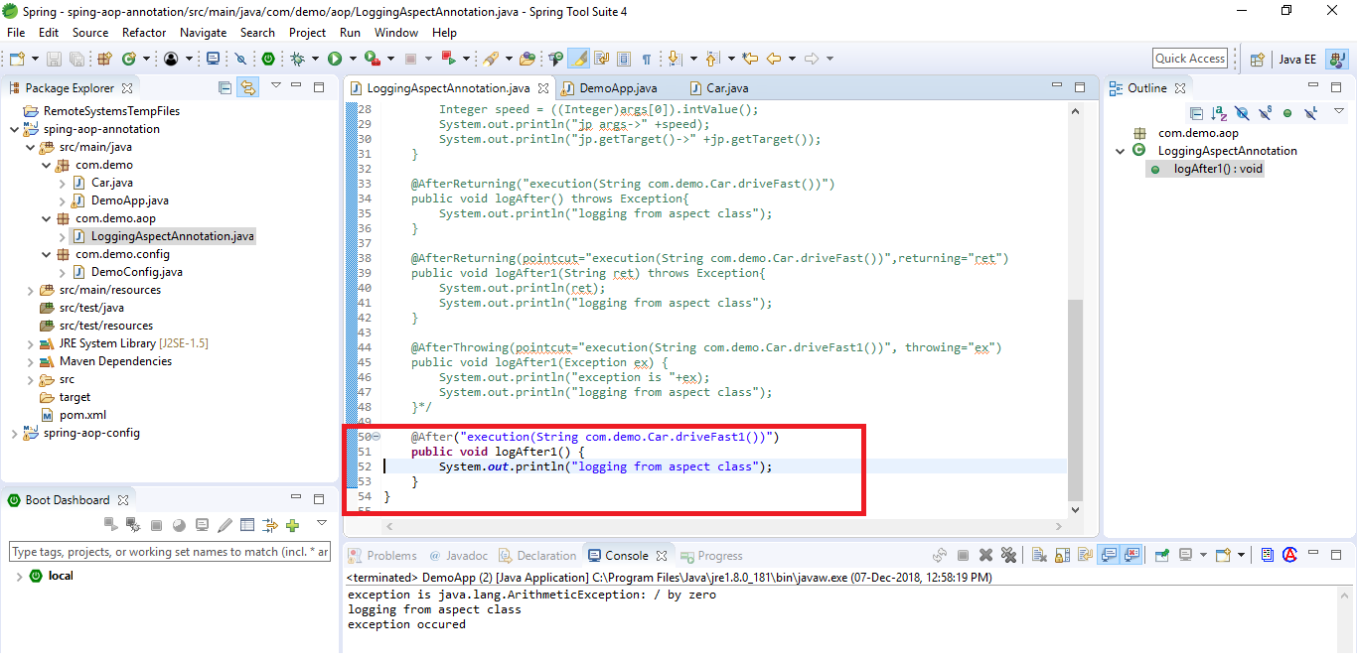

Verify if method executes without throwing any exception

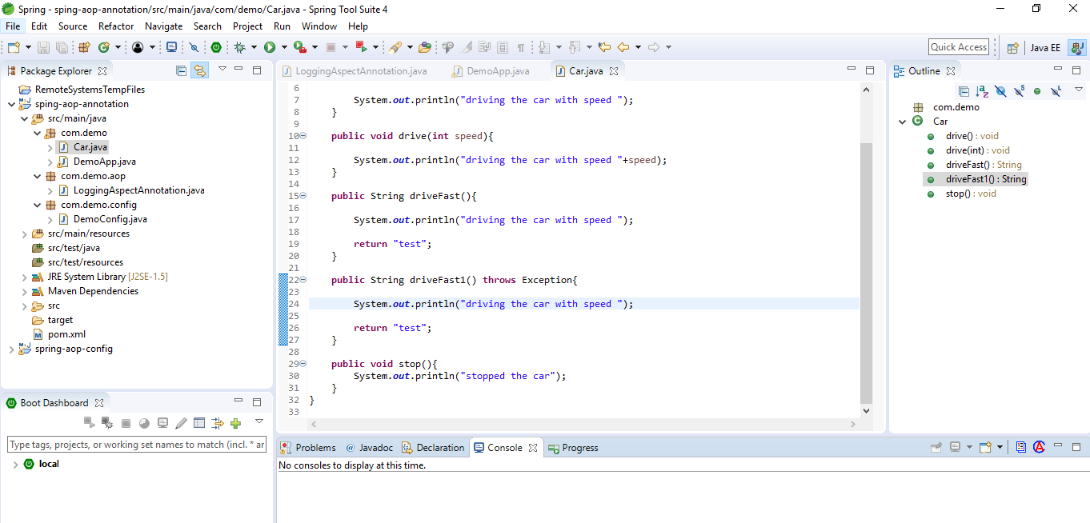

Run and verify

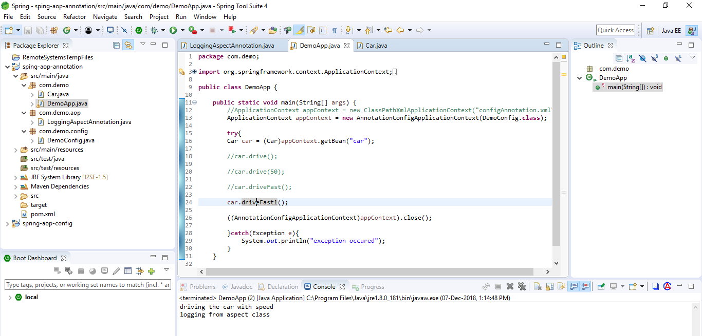

Verify if method with exception

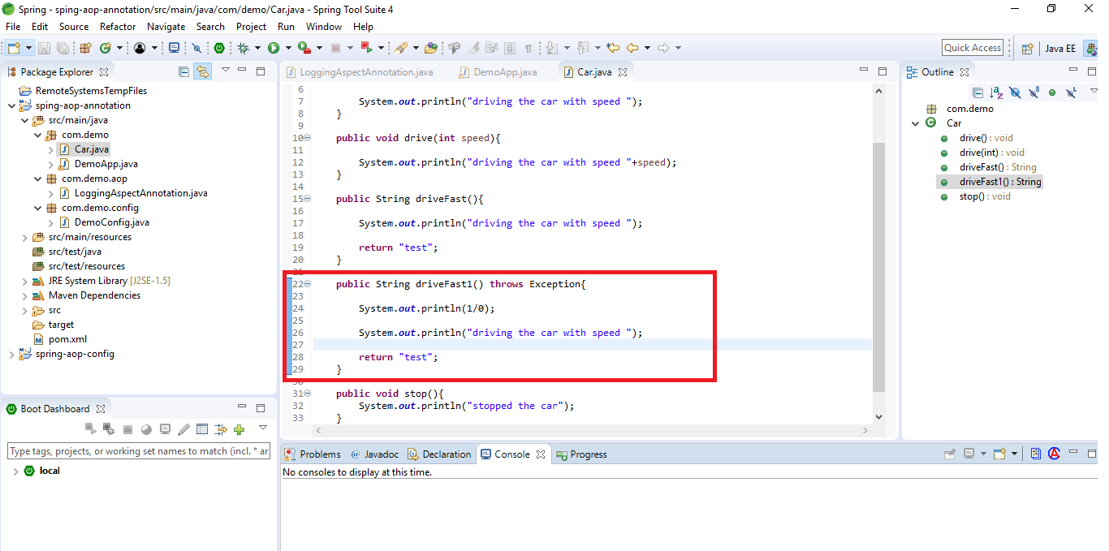

Run and verify

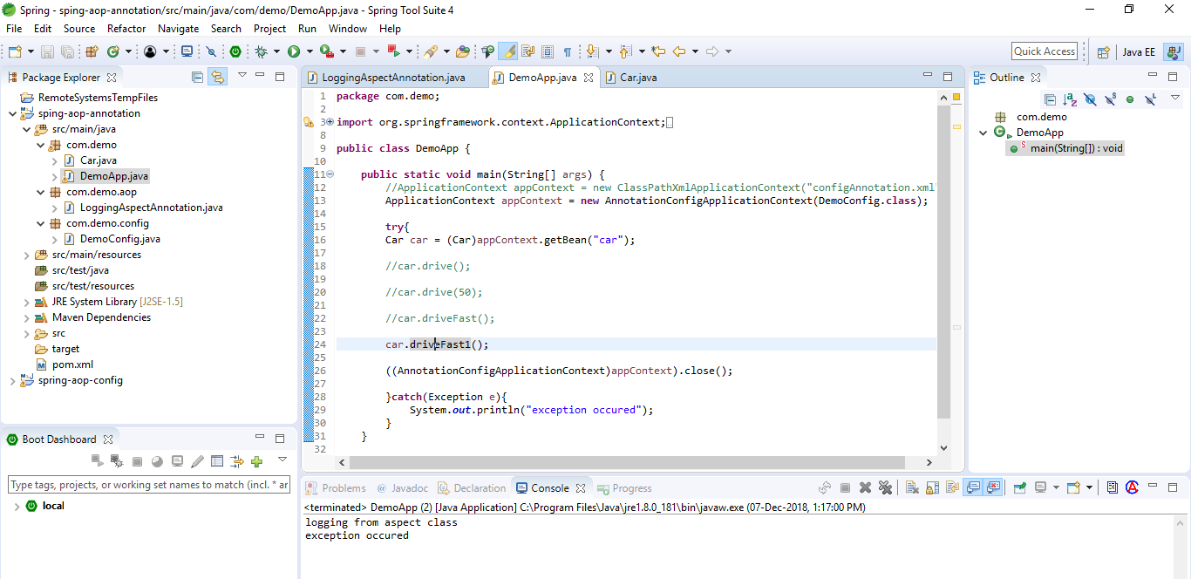

Around advise

Advise runs before or after a pointcut expression irrespective of method running normally or not

Create a method that takes a parameter and returns a value

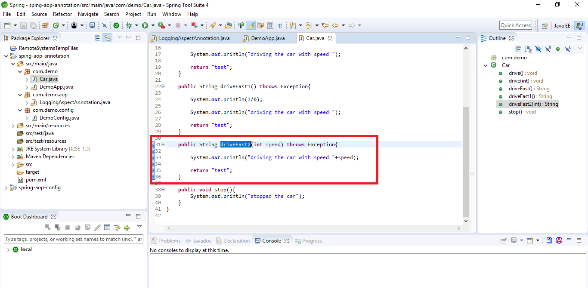

Create an around advise

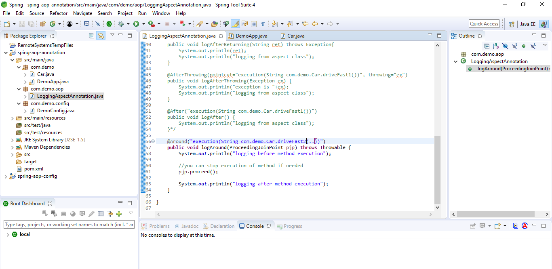

Run

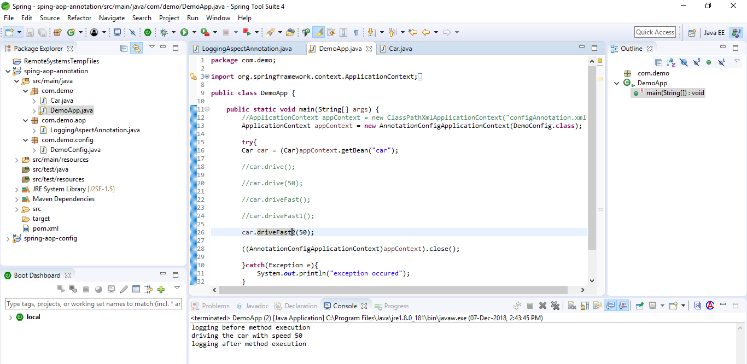

Remove proceed in advise and run

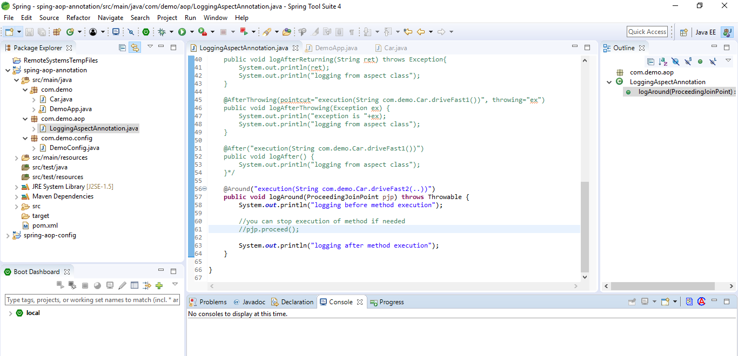

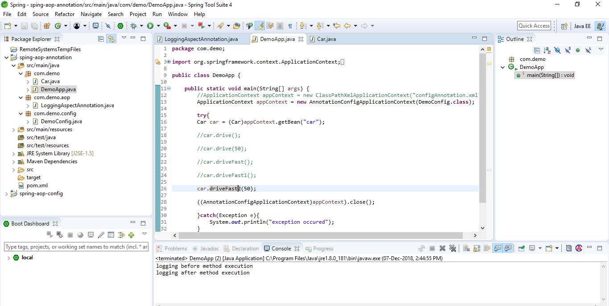

Try with exception

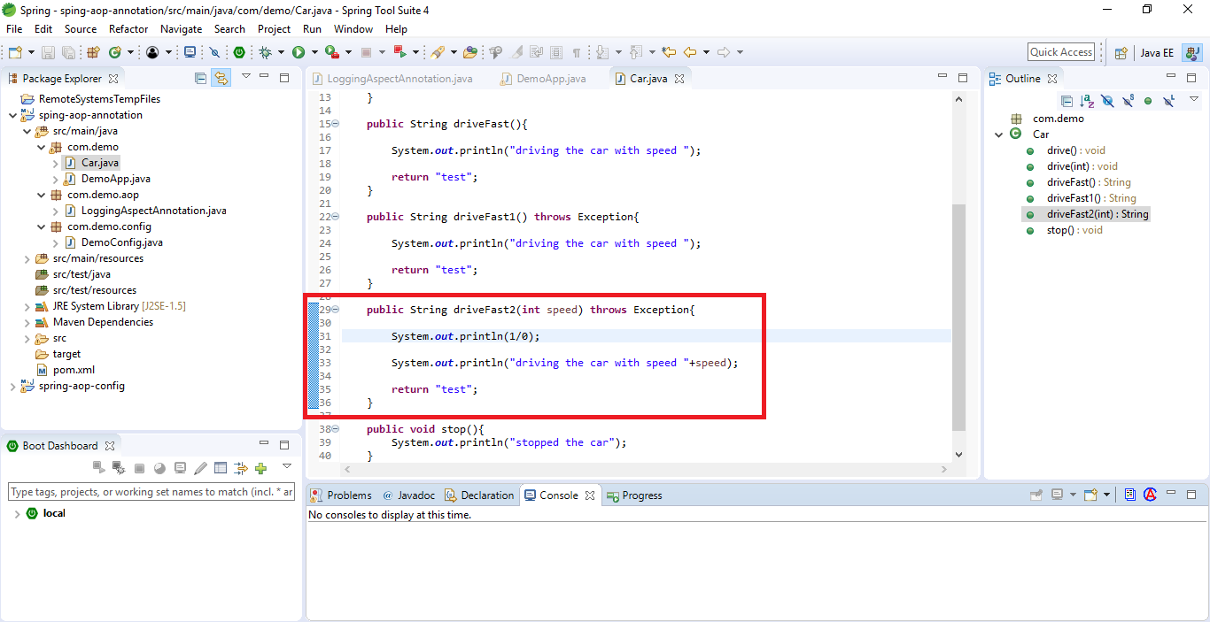

Run

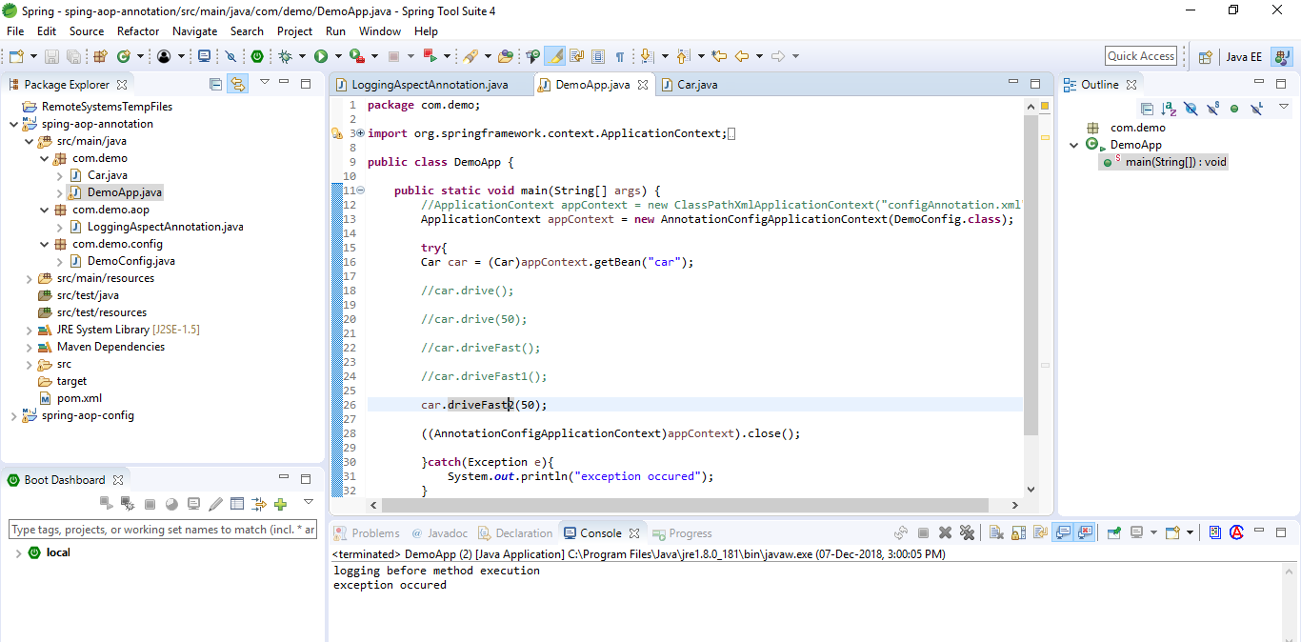

It is because we are throwing the Throwable. Catch the exception if you want to run the advise

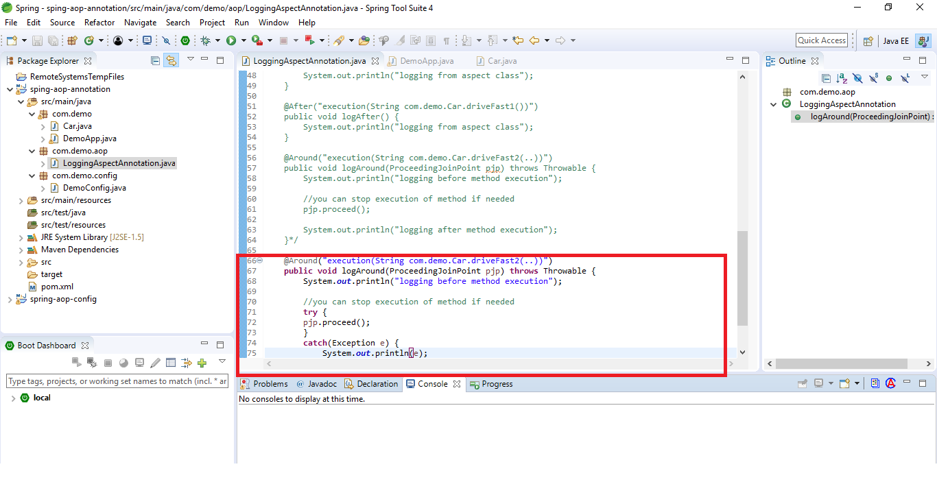

Run

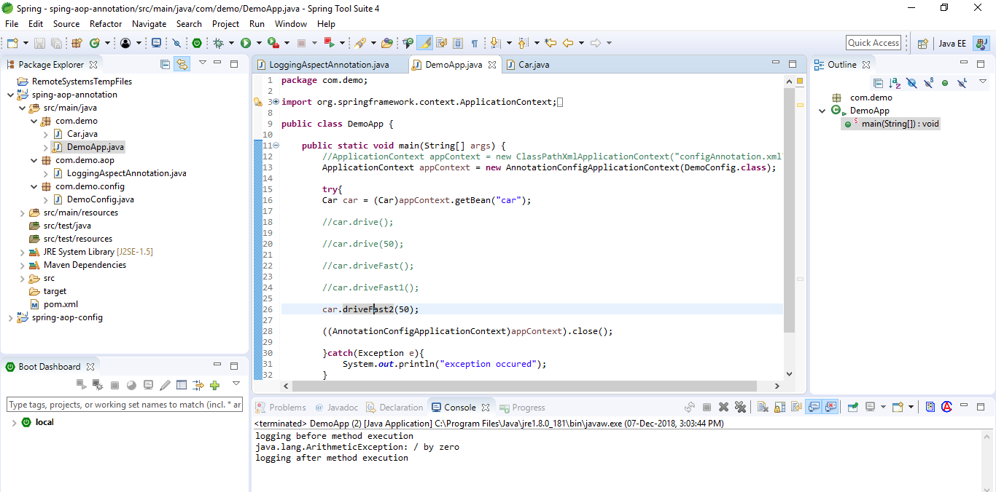

Get Parameter values

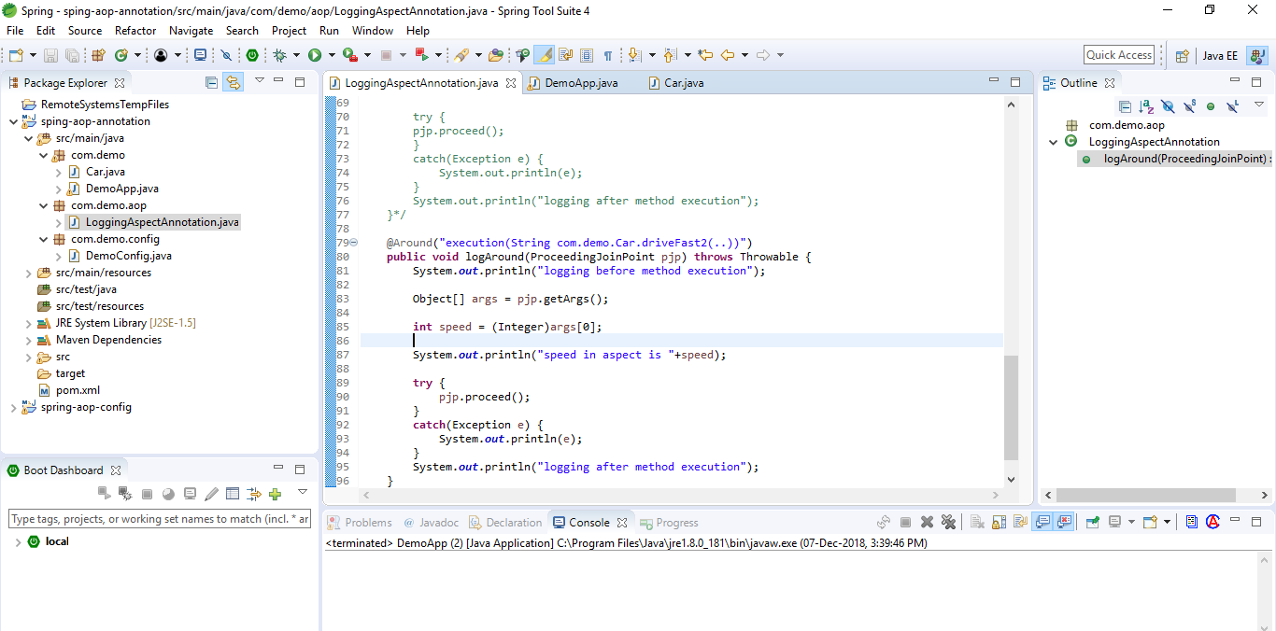

Run

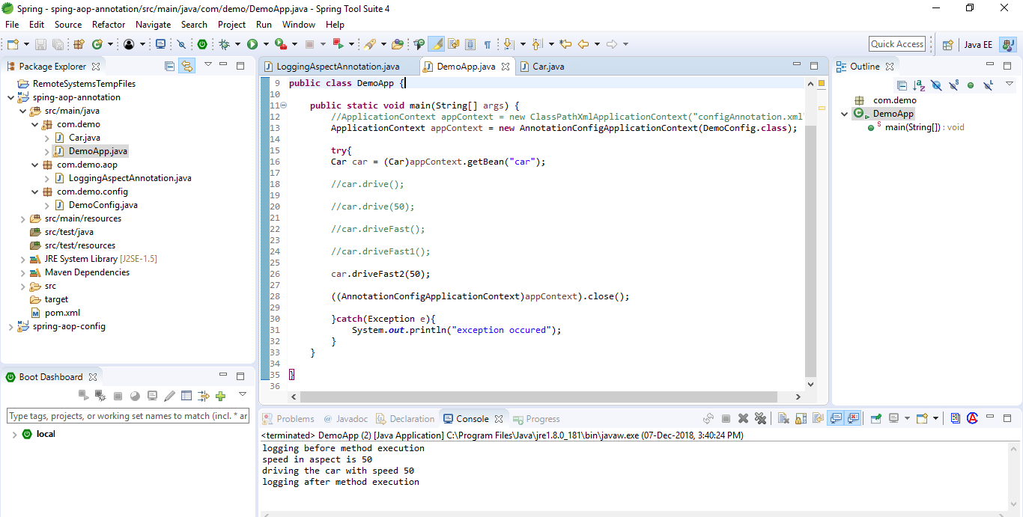

Change the parameter value

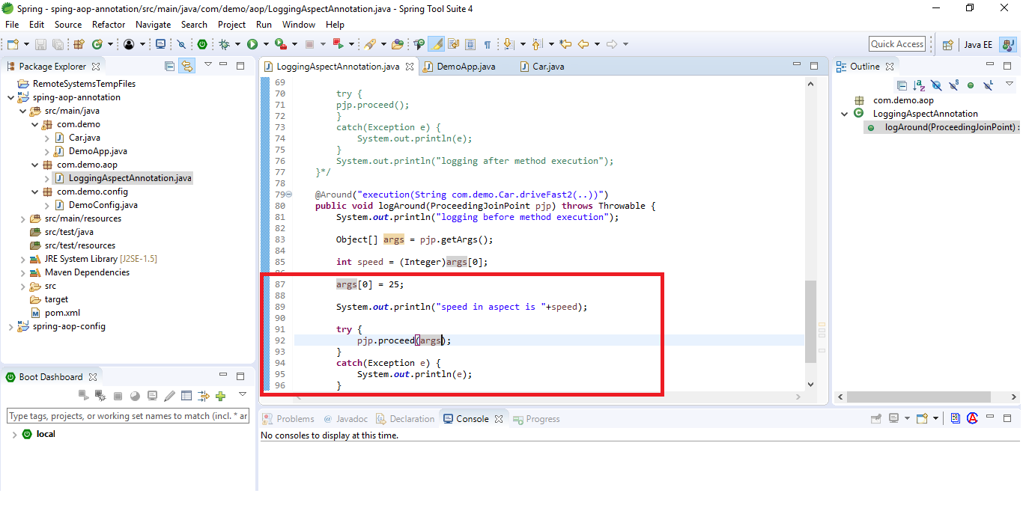

Run

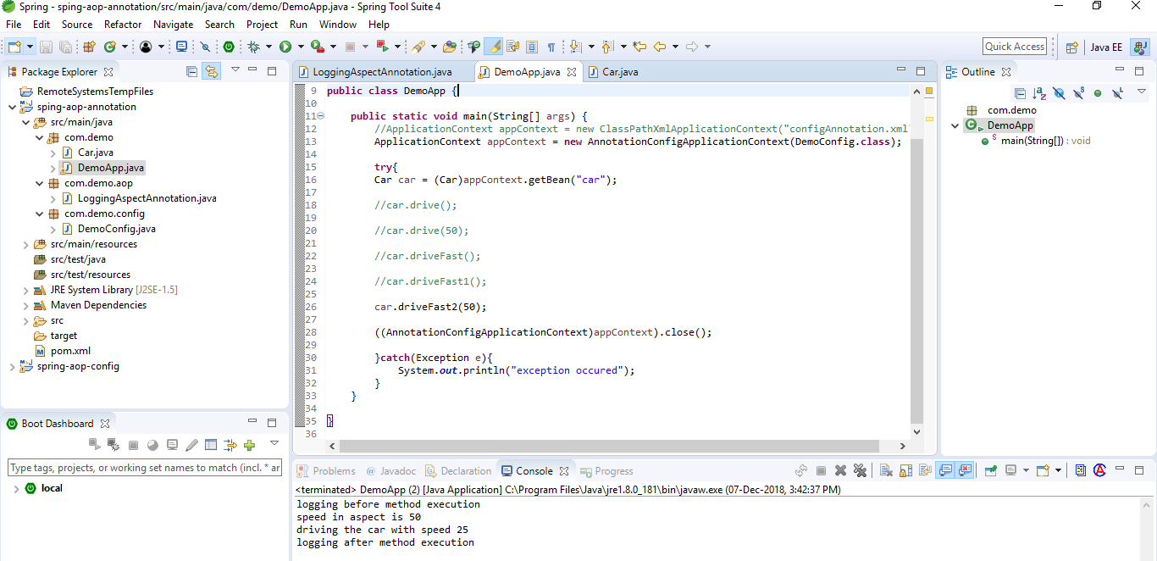

Try to print the return string in main method

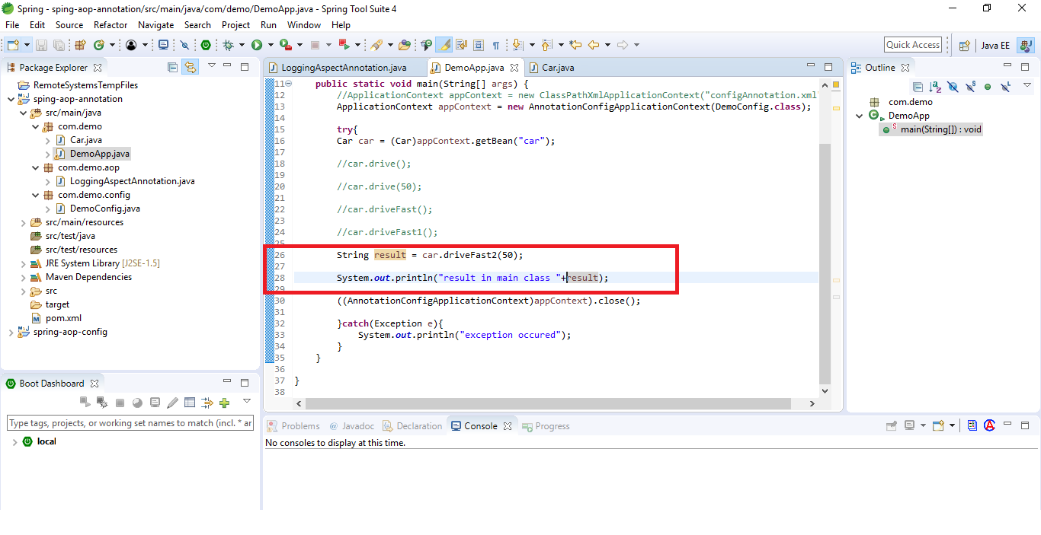

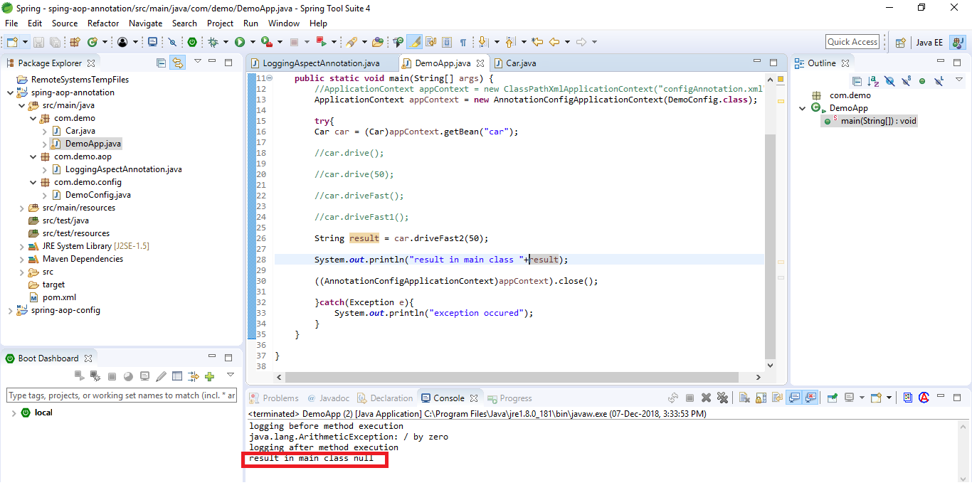

To return the value, return the value from aspect

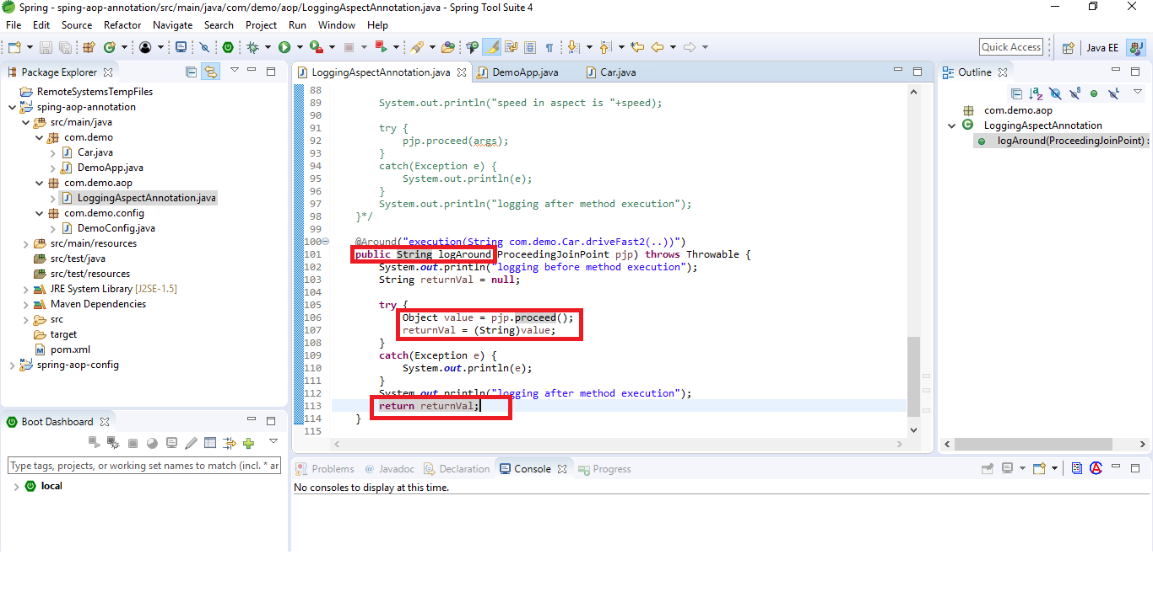

Run

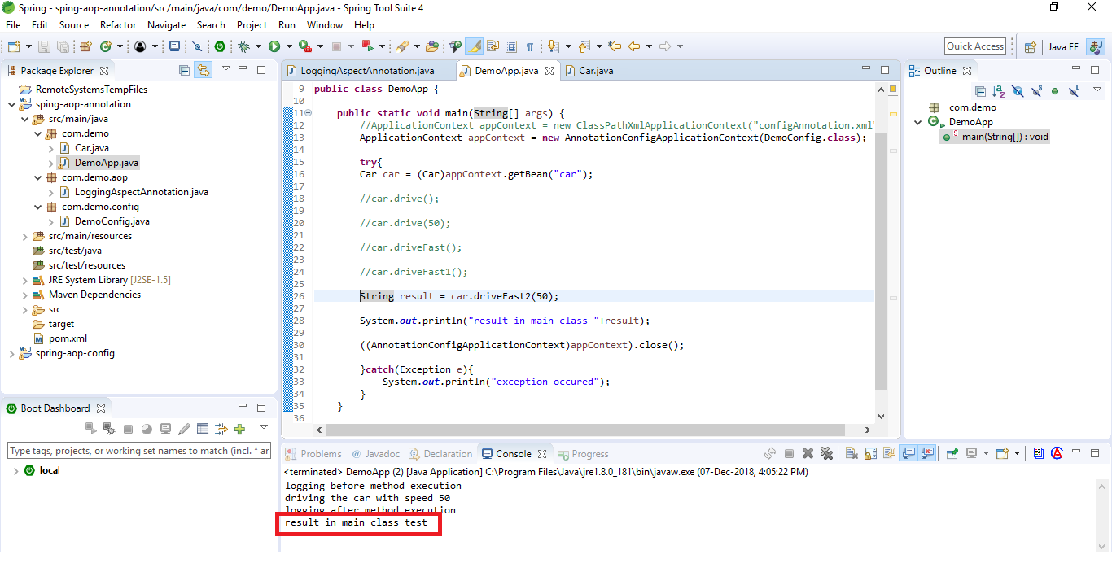

Change the return value

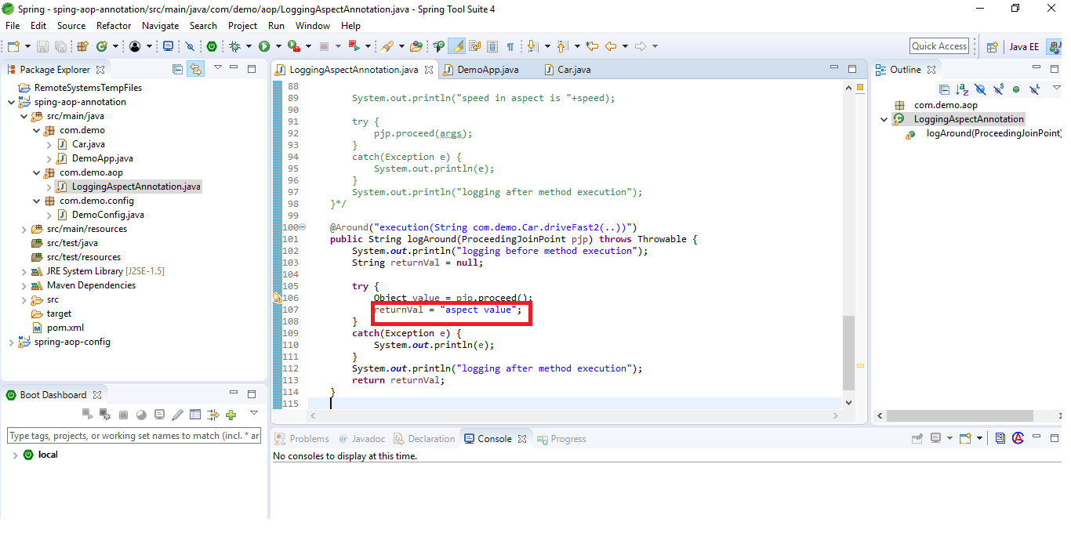

Run

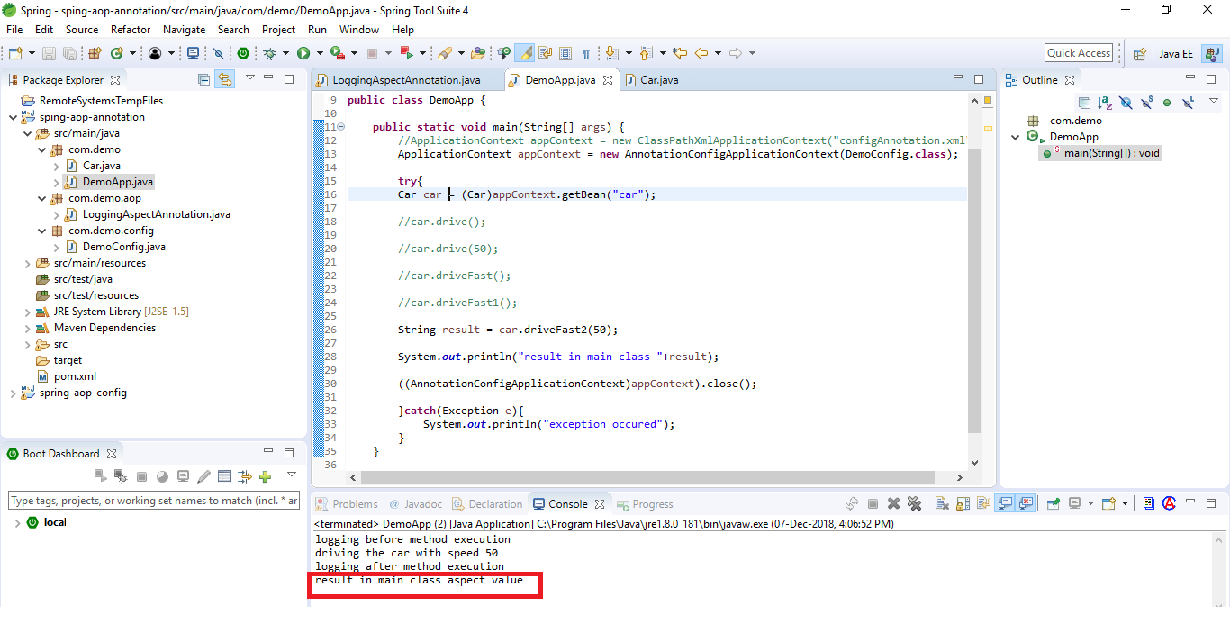

Pointcuts

Joinpoints are method executions where advise should be executed

Pointcut signature – method name and parameters

Pointcut expression – determines which joinpoints will be matched. Examples are

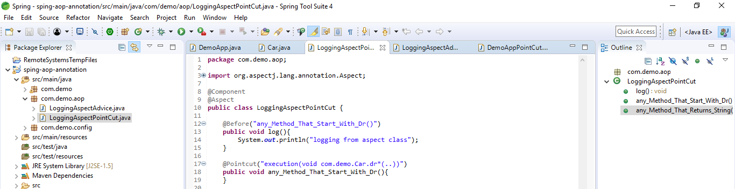

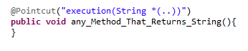

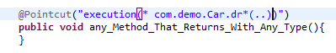

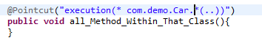

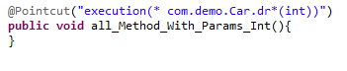

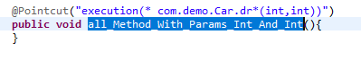

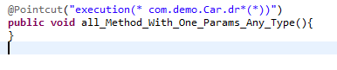

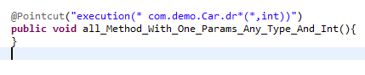

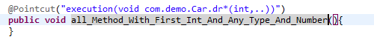

Combine pointcuts

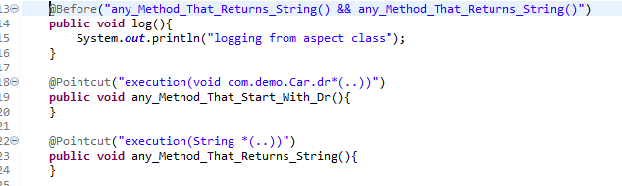

Either Or cdtn

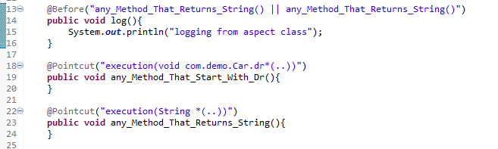

Not cdtn

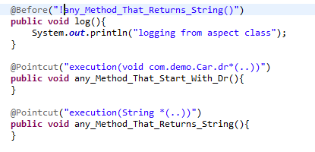

Pointcut designators

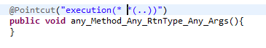

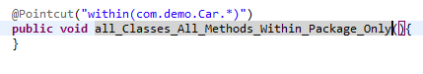

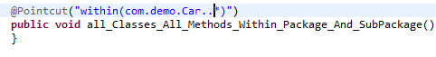

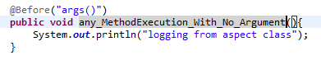

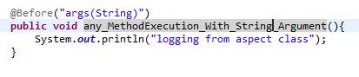

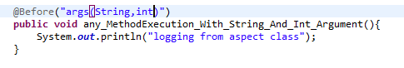

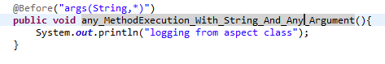

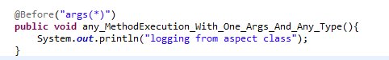

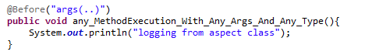

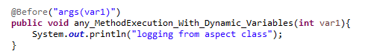

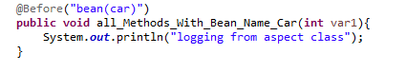

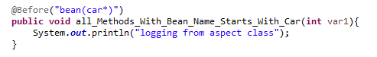

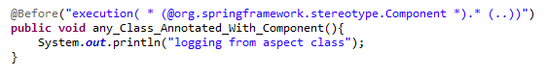

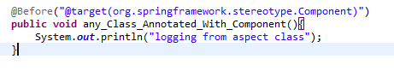

Ordering Aspects

If we havemultiple aspects in your application and they are can be applied on a certain method. When there’s more than one aspect applied to the same join point, the precedence/order of the aspects will not be determined unless you have explicitly specified it using either @Order annotation or org.springframework.core.Ordered interface

Example

Two aspects having same pointcut

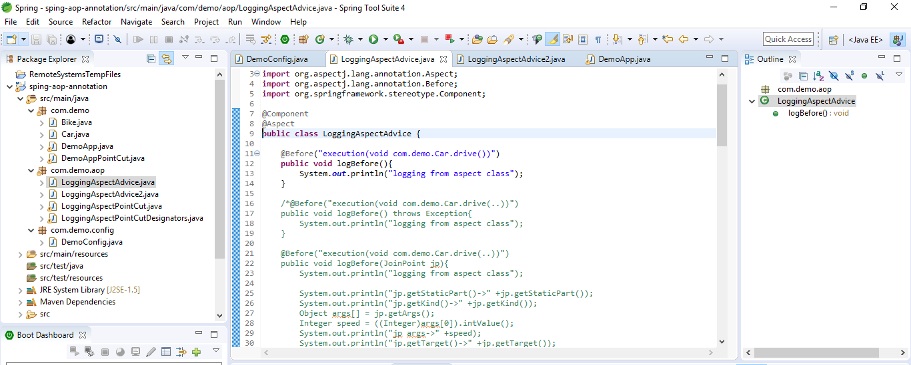

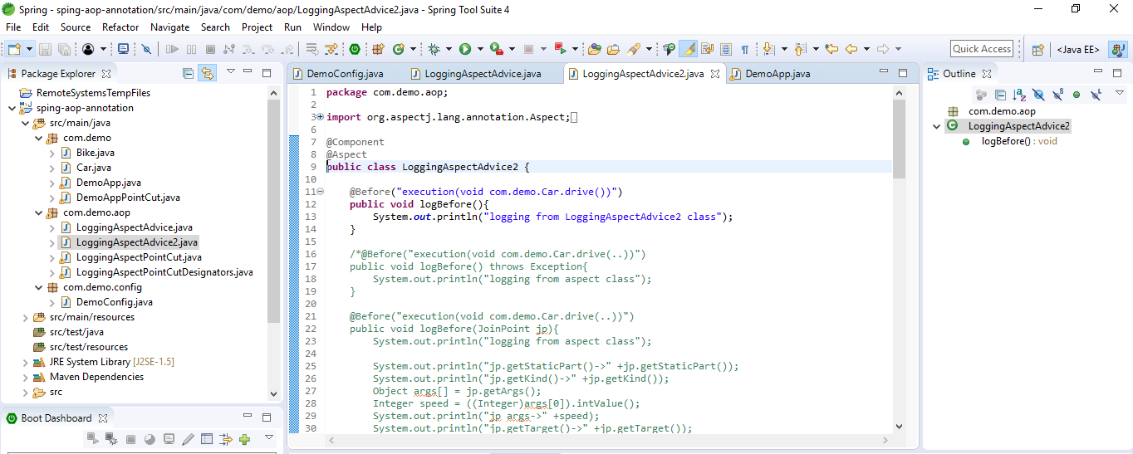

Now run

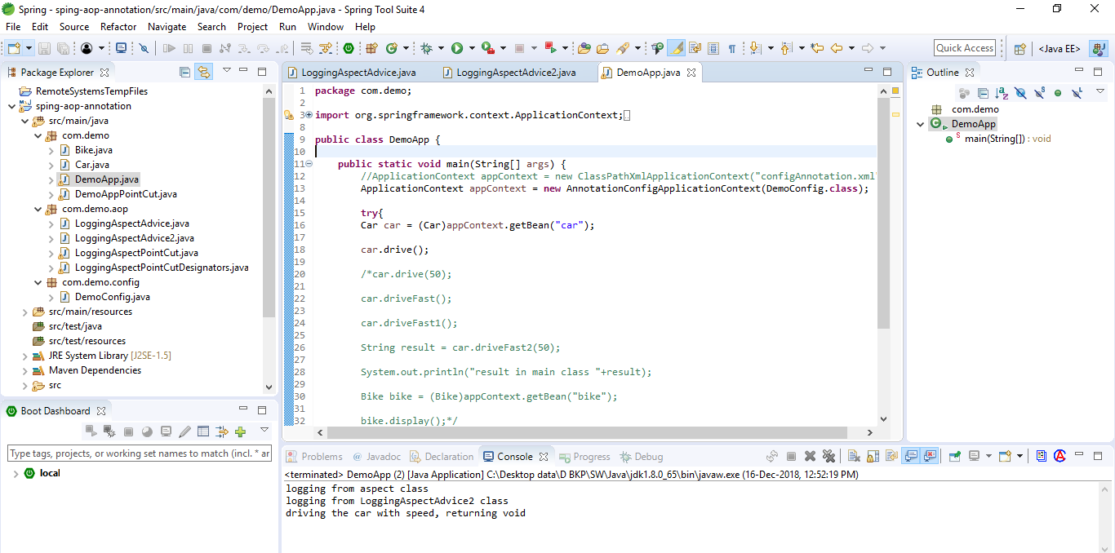

To change order, specify order. Lower value will execute first

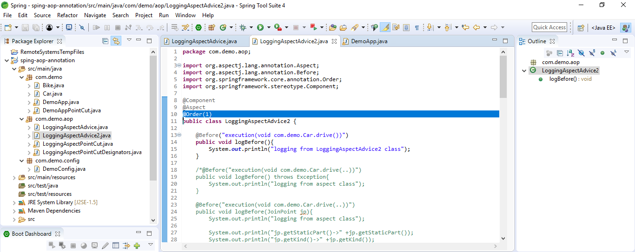

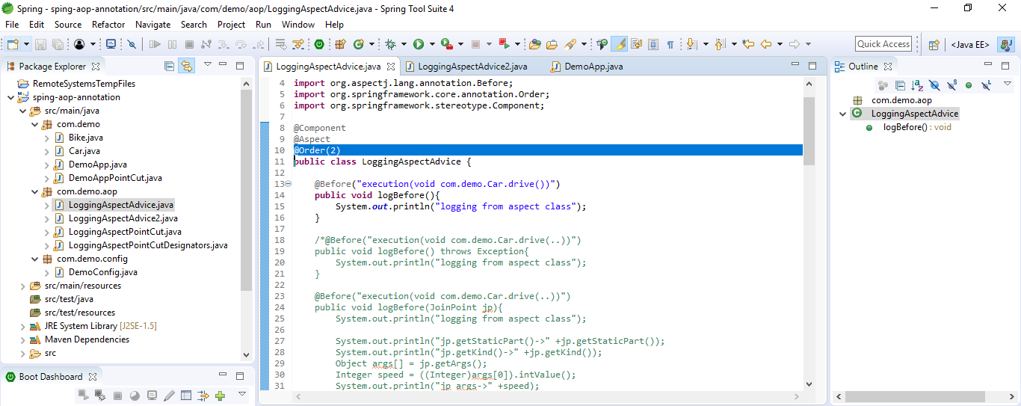

Run now

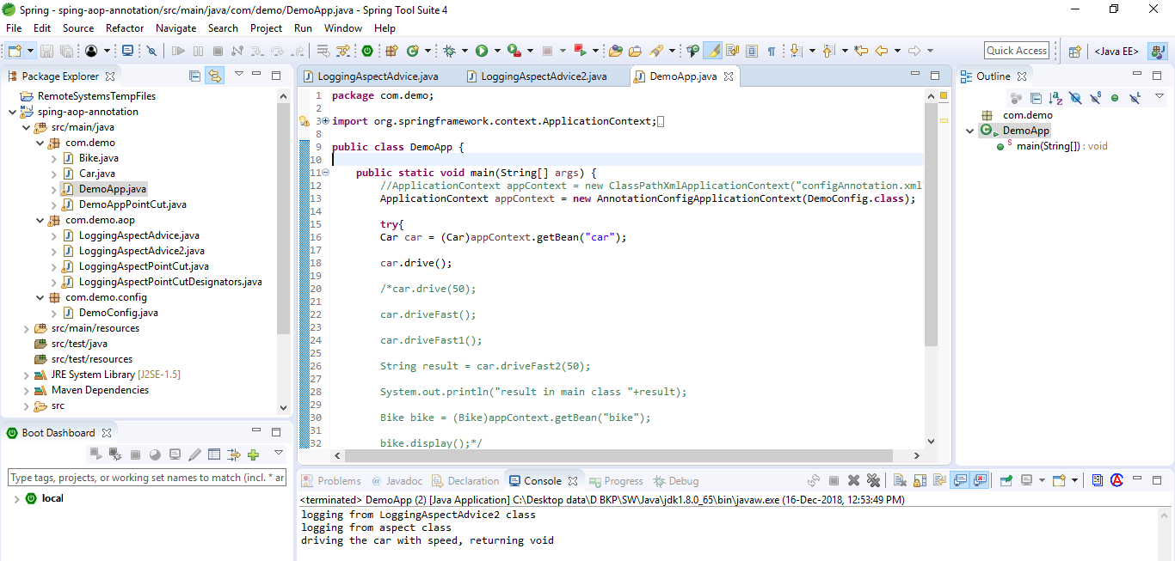

Order can be specified by implementing Ordered interface

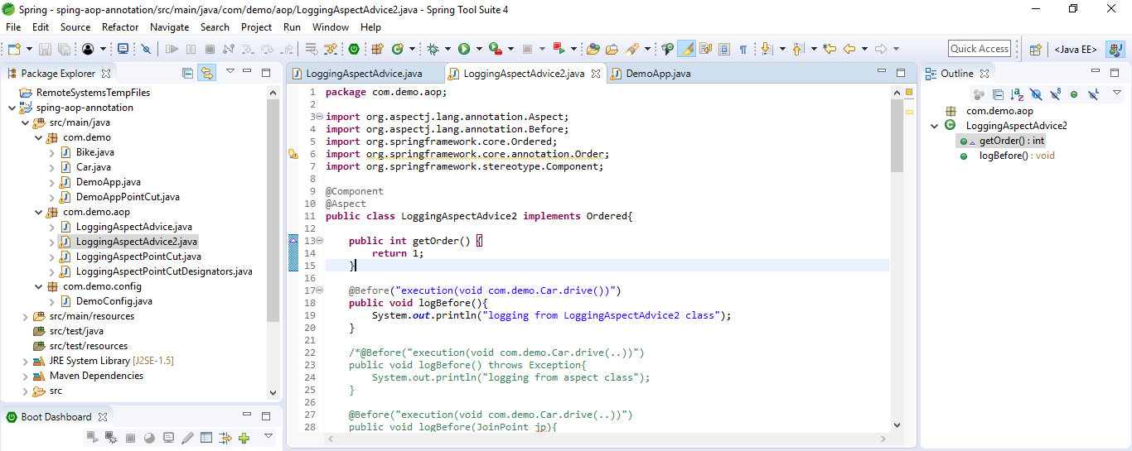

You can specify Highest precedence to run first

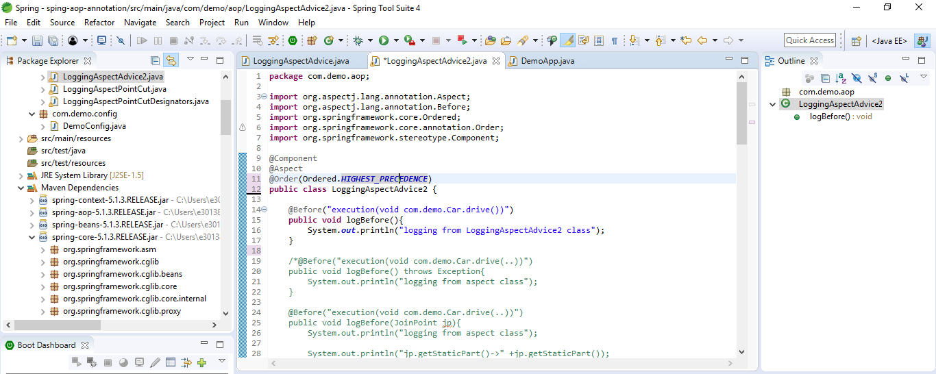

Proxy method

Spring AOP uses either JDK dynamic proxies or CGLIB to create the proxy for a given target object. (JDK dynamic proxies are preferred whenever you have a choice).

If the target object to be proxied implements at least one interface then a JDK dynamic proxy will be used. All of the interfaces implemented by the target type will be proxied. If the target object does not implement any interfaces then a CGLIB proxy will be created.

Instantiation models

By default there will be a single instance of each aspect within the application context. AspectJ calls this the singleton instantiation model. It is possible to define aspects with alternate lifecycles :- Spring supports AspectJ’s perthis and pertarget

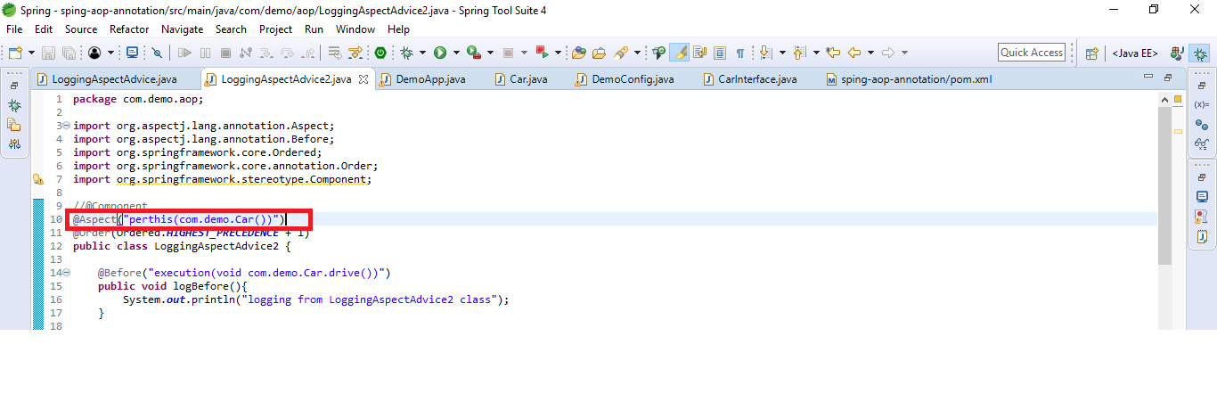

@Configurable

Dependencies required

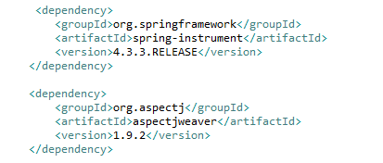

Enable annotations

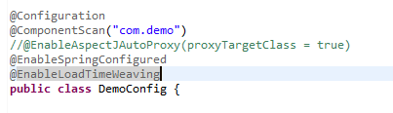

Now configure a bean within bean

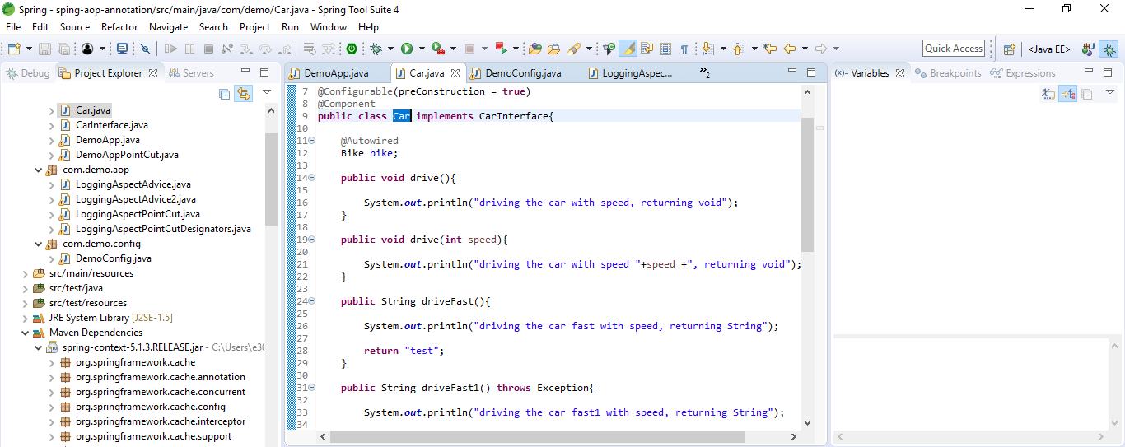

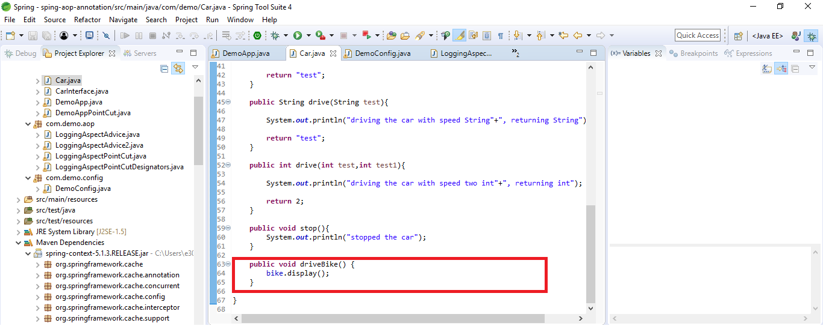

Now run it as normal java instantiation

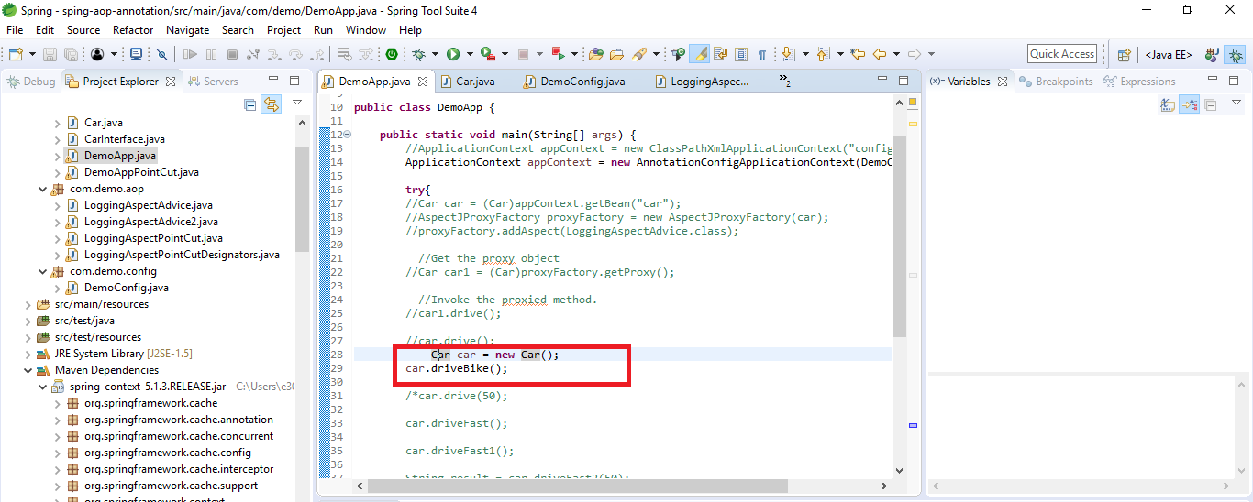

Run

